# Abstract

It is a web-based platform and also a framework which is very useful to education sector to manage the time. Firstly, all Teacher must register using the registration form which is possible by only the admin. Then registered Teacher can log in with their email id and password to authenticate. When the Teacher log into the system, they can access their classes routine, exam routine, information of Teacher . Having any problems with the schedule , the project have a chat feature through which Teacher can communicate with supervisor about it personally. Notification features is also provided to the Teacher side which notify the Teacher if any change is done in the system. In the same way, the supervisor must log in through its id and password. supervisor have the crud features in the system. Adding, updating, deleting such facilities is provided to the admin. So, this project is totally handle by supervisor who have the authentication such like register new Teacher to the website as Teacher and providing id and password to the Teacher s. Until and unless supervisor register the Teacher in the system, all Teacher won’t able to access into the system.

***Keyword: Course, Exam,*** ***Routine, Schedule***

# Acknowledgement

This project was successful with the help of many people. So, I would like to thank all those who helped me to complete this project.

Firstly , I would like to express my special thanks of gratitude to TU (Tribhuvan University) and NIMS college who gave me the golden opportunity to do this project on the topic College Based Time Management system. Then I will thank Teacher (Ujjwal Bhusal) under whose guidance I have learned a lot about this project and developed an excellent project. His suggestions and directions have helped me a lot to complete this project. He motivated and corrected me while I have errors in my projects. He helped me in doing a lot of Research and i came to know about a lot of things related to this topic.

At last, I would like to thank my parents for their excellent decision, For allowing me to be part of this course. I would also like thanks my friends who have helped me with their valuable suggestions and guidance to complete the project.

# Table of Contents

Abstract IV

Acknowledgement V

Table of Contents VI

List of Abbreviations VIII

List of Figures IX

Lists of Tables XI

Chapter 1: Introduction 1

1.1. Introduction 1

1.2. Problem Statement 3

1.3. Objectives 5

Academic Objectives 5

Personal Objectives 5

Technical Objectives 5

1.4. Scope and Limitation 6

1.5. Report Organization 7

Chapter 2: Background Study and Literature Review 8

2.1. Background Study 8

2.2. Literature Review 12

Chapter 3: System Analysis and Design 15

3.1. System Analysis 16

3.1.1. Requirement Analysis 16

i. Functional Requirements 16

ii. Non Functional Requirements 17

3.1.2. Feasibility Analysis 18

i. Technical 18

ii. Operational 18

iii. Economic 18

iv. Schedule 18

3.1.3. Data Modeling (ER-Diagram) 21

3.2. System Design 24

3.2.1. Architectural Design 24

3.2.2. Database Schema Design 25

3.2.3. Interface Design (UI Interface / Interface Structure Diagrams) 26

3.2.4. Physical DFD 33

Chapter 4: Implementation and Testing 34

4.1. Implementation 34

4.1.1. Tools Used (CASE tools, Programming languages, Database platforms) 34

4.1.2. Implementation Details of Modules (Description of procedures/functions) 40

4.2. Testing 42

4.2.1. Test Cases for Unit Testing 42

4.2.2. Test Cases for System Testing 43

Chapter 5: Conclusion and Future Recommendations 44

5.1. Lesson Learn / Outcome 44

5.2. Conclusion 45

5.3. Future Recommendations 45

Appendices 46

References 56

bibliography 56

# List of Abbreviations

**Table 1****: List of Abbreviation**

|  |  |
| --- | --- |
| Abbreviations | Full Form |
| AJAX | Asynchronous JavaScript And Xml |
| CRUD | Create Read Update Delete |
| CSS | Cascading Style Sheets |
| DBMS | Database Management System |
| DFD | Data Flow Diagram |
| ER DIAGRAM | Entity Relation Diagram |
| HTML | Hyper Text Markup Language |
| JS | JavaScript |
| PHP | Hypertext Preprocessor |
| SQL | Structured Query Language |
| TU | Tribhuvan University |
| UI | Teacher Interface |
| XAMPP | Cross-platform Apache MySQL PHP and Perl |

# 

# 

# List of Figures

Figure 1.2: Problems Statement 4

Figure 1.2: Problems Statement_Solution 4

Figure 1.3: Objectives 6

Figure 3: Waterfall Methodology 15

Figure 3.1.: Use case 16

Figure 3.1.2: Schedule_Gantt chart 1 19

Figure 3.1.2: Schedule_Gantt chart 2 19

Figure 3.1.2: Schedule_Gantt chart 3 20

Figure 3.1.2: Schedule_Gantt chart 4 20

Figure 3.1.2: Schedule_Gantt chart 5 21

Figure 3.1.3: E-R Diagram 21

Figure 3.1.4: level 0 DFD 22

Figure 3.1.4: level 1 DFD 23

Figure 3.1.4: level 2 DFD 23

Figure 3.2.1: Flow-chart 24

Figure 3.3.2: Database schema 25

Figure 3.2.3: home page UI 26

Figure 3.2.3: Login UI 26

Figure 3.2.3: supervisor page UI 27

Figure 3.2.3: Schedule UI 27

Figure 3.2.3: Information UI 28

Figure 3.2.3: Message UI 28

Figure 3.2.3: Register UI 29

Figure 3.2.3: Teacher page UI 29

Figure 3.2.3: Teacher Exam UI 30

Figure 3.2.3: Teacher Course UI 30

Figure 3.2.3: Teacher Information 31

Figure 3.2.3: Teacher Notification UI 31

Figure 3.2.3: Teacher Chat UI 32

Figure 3.2.4 : DFD 33

# Lists of Tables

Table 1 : List of Abbreviation VIII

Table 2 : Chapter: 4.1.1 CASE tools 34

Table 3 : Chapter: 4.1.1 Programming tools 38

Table 4 : Chapter 4.2.1 Unit testing 42

Table 5 : Chapter 4.2.1 System testing 43

# Chapter 1: Introduction

## 1.1. Introduction

Time management system is the system which use the time more effectively, so that the activity can be the done on right times,project tasks can be completed and progress can be achieved. In order words, it can be said as the planning or organizing to divide the time for the specific activities in systematic manner.

Talking about time management, day to day life every people have their own schedule of time. From Waking up from bed and back to the bed. It shows every people are waking with the flow of time which can be said as understanding the power of time and utilizing or analyzing it. Walking with time by understanding it leads the people towards progress, development, goals, and their dreams. So, people started managing the time by planning, scheduling, and implementing it to complete the specific tasks on abbreviated period which save their times.

As it comes about organization or companies (numbers of employees) time management system are must need to divides the time as per employee’s tasks are separated. So, time management system is done in every field whether it is in education sector or in business sector because by managing the time, it will make you to complete the tasks in abbreviated period of time and for that the planning, scheduling, monitoring, and controlling of all project activities are required.That’s why time management system is required in every field to complete the tasks and to achieve progress in systematic ways.

So, I have chosen time management system based on college. Managing the system of the college according to the real time base which may be date, day, months, hours, minutes, and seconds, etc. According to the college, one person is need to manage time who is supervisor and the people to following the time as managed, who are Teacher . supervisor is the person who play the role of managing the time and to run college in systematic way. Teacher are those peoples who will be under the supervisor and work as per the system. So, this will show one to many relations between supervisor and Teacher .

Time manage system is done whether in document paper form to keeps records of Teacher personal detail like name, address, email, phone numbers, course, subject and according to the informal the planning, scheduling, and meeting to discuss about how to achieve the goals in the right time. But as it is done in paper form current changes takes time. If Time management system is not managed in the college it might create some issues to the Teacher and admin. They are like:

* Cannot complete the tasks/course on time
* Creates confuse between Teacher about course time
* Creates non-systematic/non-seriousness
* Creates wrong decision
* Cannot create good relationship between supervisor and Teacher
* Update in the time management may not know by every Teacher

So, online time managing technology is created to overcome all the paper form problems. It reduces wastage of time and bundle of paper. Information can be achieved from anywhere without being inside the organization. Only they have to login in the website with their id and password as given by the admin. Teacher can see the schedules. Sometimes the supervisor can update in routine which Teacher might not know. So, it automatically sends notifications to the Teacher . And if they have any problems with changes their can simple message personally to the supervisor about it.

So, supervisor will keep the records of college information like planning, attendance of Teacher , course time, routine, meeting, and personal information of Teacher . This helps the supervisor to monitoring and to systematic in college.

**‌Scheduling Time**

To separates the time for the course according to the Teacher , supervisor need to analysis whether Teacher can give time or not for the course. Course is required to finish in the given period. It will deal with the course id, course name and course type as separated for the Teacher .

**Class ‌Routine**

To create Class Routine for the Teacher , supervisor need to separate the tasks along with its time , subject, date and Teacher . It helps Teacher to work as per schedule and make them to complete their tasks on time. It creates sequences in working with the flow of time and systematic manners in the college.

**Exam ‌Routine**

To create Exam Routine for the students, supervisor required the time table, subject along with code and location where exam will be held. It helps Teacher as to be ready for exam as invigilator.

**Teacher Records**

Keeping the records of the Teacher with their details which will make much easier to know the Teacher information and theirs roles in the college.

## 1.2. Problem Statement

In education sector, some problems may occur like; change is done in the time schedule or in routine might not know by the Teacher . Sometimes Teacher might not be able to take class due to their personal reasons like sick, accident, being late. Sometimes Teacher may have taken class and have not presented in the attendance which might create misunderstanding/conflict between Teacher and admin.

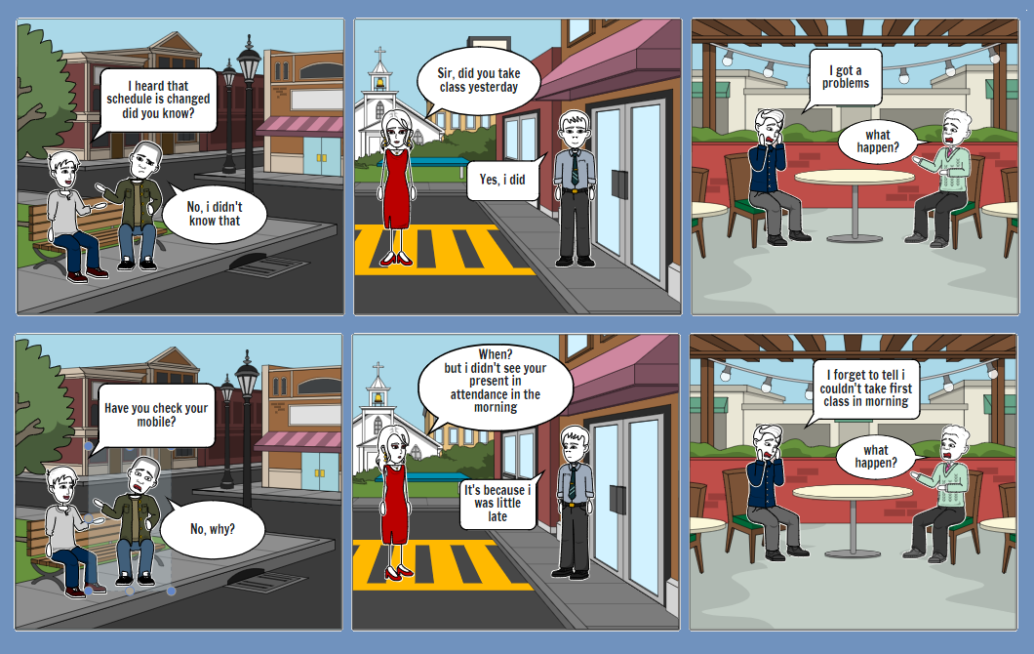

**Figure 1****: Chapter 1.2 Problems Statement**

**Solution**

As we have problems that might create non-systematic in education sector and might not leads towards goals. So, I have some solutions which might create systematic and helps to achieve goals use technologies. Even changes are done in schedule or routine by the admin. It will automatic sent notification about the updates to the Teacher individually but they have to login in websites with their Id and passwords. Id card will be provided to the Teacher as they register their name with their email id and password in the websites. Once register is done, Teacher will have to use their ID card to keep record of attendance. If Teacher cannot take class due to some reasons, he/she can personally message to the supervisor about the problems and supervisor will manage the schedule.

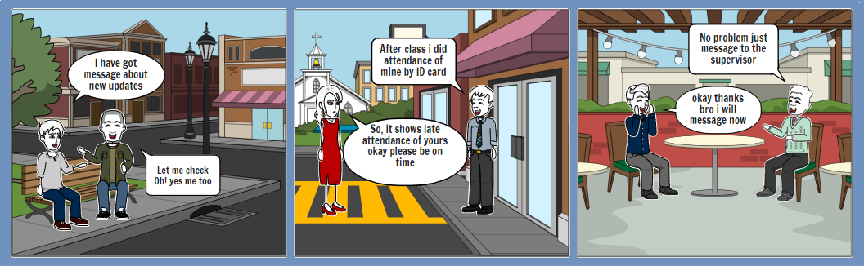

**Figure 2****: Chapter 1.2 Problems Statement_Solution**

## 1.3. Objectives

The Main objective of project on College Based Time Management System(Routine) is to creates systematic in uses of time.

* To complete the tasks/course on time
* To creates understanding about course time
* To creates systematic and seriousness
* To creates right decision, planning and achieve progress
* To creates good relationship between supervisor and Teacher
* To update in the schedule known by every Teacher

### Academic Objectives

* To use the academic skills and knowledge to manage the time
* To have knowledge of Teacher performances, activities, and behavior
* To have knowledge of managing the time (Routine) online
* To build good relationship with Teacher and admin
* To saves the time and providing notifications along with chat features

### Personal Objectives

* To complete the project on dead line (as challenge)
* To have real life experiences on this project
* To create theoretical project (as studied) into Practical project
* To compete with related project in the market after graduation

### Technical Objectives

* To have knowledge of websites using different languages like JavaScript, html, SQL
* To design the project along with flexibility so, it can update in the future
* To make adaptability on any devices like android phone, tablets, laptop and, etc.
* To make the system more secures with login features

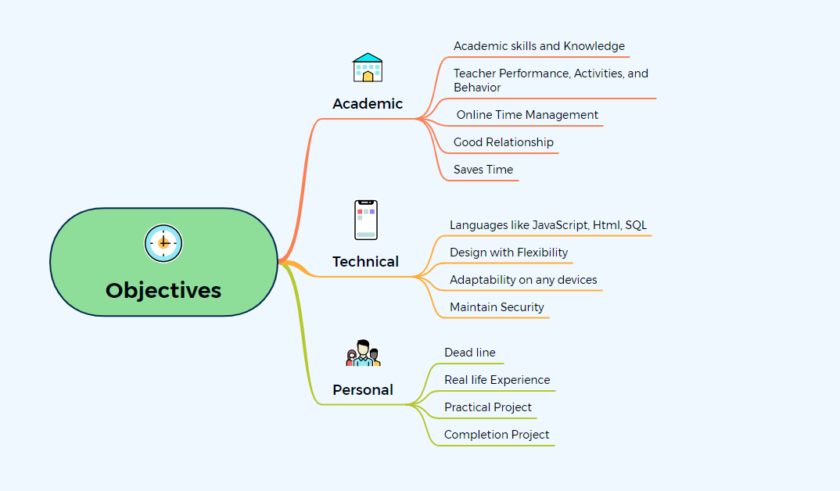

**Figure 3****: Chapter 1.3 Objectives**

## 1.4. Scope and Limitation

The scope of time management project is that both supervisor and Teacher can use it as supervisor and Teacher respectively. They have to login to register. Once they login, they can access it from anywhere. It creates good relationship between them. It automatic saves the information of the Teacher performance (determines the progress of the Teacher ). It has the features of communication and notification will help the Teacher to be updated with the schedule. It is quite easy to use and does not required well skilled. Talking about field, it is also used in business, educational, hospital, industrial and office sector which helps to achieve their goals.

The limitation of time management project is that the both supervisor and Teacher have to be online otherwise they can’t use it. Teacher cannot login or use the website until and unless supervisor register their name as a Teacher . supervisor only have the authority to updates in the websites.

## 1.5. Report Organization

The font for the report is numbered in times new roman from page number 1. The page number should be inserted at the bottom, aligned is in center. The margin of paper must be set as Top = 1, Bottom = 1, Right = 1, Left =1.25. The paper size corresponds to A4. All paragraphs must be justified and have a spacing of 1.5 and the content of the document should be in Times New Roman Font. The font size for the heading is 16 where section heading, sub-section heading and paragraph have 14, 12 and 12 respectively. All the headings are bold faced. The position of figures and tables should be aligned center. The figure caption should be centered below the figure and table captions should be centered above the table. All the captions should be of bold face with 12 font size.

There's Five chapters which have different steps of developing the main projects(Time management). We have introduction with background related to time management along with it’s problem statements, objective, scope and limitation and report organization in chapter 1. where as in chapter 2, we have background study and literature review of the project. Similarly in chapter 3, We have system analysis and Architectural Design. In System analysis, it includes requirement analysis, feasibility analysis, Data modeling (ER-DIAGRAM) and Process modeling. Where requirements analysis includes functional requirements and non-functional requirements. in Feasibility analysis, it includes Technical, operational economic and schedule. And Architectural Design includes Database Schema design, interface design and physical DFD. In chapter 4, We have implementation and Testing. Where implementation includes Tools used and Implementation details of modules. And Testing which includes unit testing and system testing.As chapter 5 is the final chapter which consist of lesson learn(outcome), conclusion and future recommendations of the project.

# Chapter 2: Background Study and Literature Review

## 2.1. Background Study

The time can be simply defined as the duration between any two events. The process of planning and organizing the time with different activities is called time management. Time management is one of the most important infrastructure for the day to day achievement in various fields of human life. One can perform various works without wasting the time. The time management makes the person smart and organized as well. The way to manage the time and the activity that are kept in priority are different in different ages of human life.

The time and time management as we know it is very important for the human beings to live a happy life. Every people have their own ways of living life, even in business, office, college, school and industry fields they also have their own time tracking scheduling. From centuries to centuries, many revolution of time along with daily activities has occurs which was because of the human curious nature. There are many devices that does not only tells the accurate time but also keep the records of many things. For examples smart watch, mobile, computer, etc and many software like Ms-Excel, etc which helps to measure and shows the accuracy records with time. Such like heart beat, miles of walking, daily activities, money banking online, distances, tracking time, locations, alarm, showing deadline, sent notification, etc.

As talking about the history of time formation devices, there were many time devices were invented to measure the accurate length of time and as well as methods of keeping the way of time management records. As we know that the ancient peoples’ daily life began with the sunlight and ends with the sunset. Since there were no further development in the technology, people in the ancient time were not able to fully use the 24 hours’ time period and utilize the time more accurately.

Around 4000 BC, In Paleolithic Period, the cave man just follows the sun and wind as per day to day life as it was their time. As sun rises, the cave man goes for the hunting and return back to the cave when sun sets. And they used write a symbols structure in the wall which is knows as cuneiform writing. Cuneiform writing which shows the days past as counting the numbers of day they survive and birthplace as record keeping. Cuneiform writing was only understood by their own people. It was their time schedule of living a life. [6]

Around 2000 BC, the Egyptians started tracing the sun’s movement as to measure the time using the device which was named as sundials. It generally work on the bases of the sunlight. The nail was attached with the woods along with some mark of number when sun’s light touch it and form shadow. The shadow indicates the number mention in the woods as time. As it dependent only upon sunlight, their time was divided into 12 hours. [2] The sundials was used as for the day to day activities for agriculture and was used to set the standard for providing the wages to the employees. Their way of keeping the records in the stone form which was known as Code of Hummurabi. Code of Hummurabi is the oldest written law which included punishment, social class and gender, minimum wage for workers,etc. [1]

The candle clock and the sand glass device was invented by the Ancient Chinese which was quite famous and used in Europe, India, and Persia. These devices use their some substance which helps to measure the time. In Sand glass, sand was used inside the glass containers which is transparent. The sand falls downward slowly and measure the length of time. Where in water clock and candles, the water is drop in a containers with the wheel attachment and wax was burnt with mark of the length of time in the height of candles respectively which were used to shape the time at that time. Sand glass was generally used for cooking, as like for 1- 5 minutes and it was reusable. [3]

In the 17th century, the Pendulum clock was invented by Christiaan Huygens which was used as the originator of timekeeping devices. the pendulum clock was the world's most precise timekeeper and accounting for its widespread use. pendulum clocks was used as primary time standard in homes, factories, offices, and railroad stations for scheduling work shifts, daily life, and public transportation. In somehow it was accuracy for the industrial revolution even it was not in present day. [3]

In 18th century, (time tracking) Pen and papers system were invented as to keep the record as worked time payment between employee and employer. Benjamin Franklin introduce the time as “time is money” because of the workforce started to shift from independent work to an employee-employer business model. That time, the effective time management was increasing and employers wanted to make sure about only that they have paid for the time worked by employees. But there was one problems also generated that employees also wanted to keep the record of received the payment for their worked time. So for the time tracking methods, pen and papers recording system were used to solve the bookkeeping errors. It brought a system which was time consuming, relied heavily on truthful and accurate recording. The system like autobiography of Benjamin Franklin and Letts diary (John Letts) was first commercial diary which was used to keep the track of stock movements. It helped merchants increase efficiency day to day. It was wild popular at that the time as it keep the record of merchants and traders. [5]

As leaders and enlightened thought, slowly the society began to have sign of maturity and symbolized the child is grownup after wearing of a watch in hand. In 18th century, the schools started to organized the hours and lessons course according to the clock, created punishment system of being late and awarded as for being punctuality. As the time evolution is change and past on from centuries to centuries, the people started do theirs activities with the flow of time from waking up to and back to the bed and their ways of lives changing as systemic.

In 19th century, Frederick Winslow Taylor published The Principles of Scientific Management which shows the management of the analysis and synthesis of workflows. It started to increase productivity in manufacturing, focused on the efficiency of individual workers, quickly spread to the office, and eventually encompassed the home environment as well. [4]

In 20th century, people are starting being systematic along with time and started manage everything whether it’s business, industries, academic sector, etc in paper form.In offices,business, academic,etc mainly they used have many important files, tasks to complete, employees,etc were required a scheduling of time as per to works. What to do? And how to do? Generally, everyone had the watch to know the time but due to the only humans and papers form recorded documents started to create problems. Some of the problems faced were like hard to find the files at current time, chunks of files are being full of dusts, consuming the huge space, consuming a lots of time, having stress, etc. The planning, ideal, objectives, goal, scheduling and meeting every was done in paper recorded form.

Slowly electronic devices were invented like computer, android phone, tablets, smart watch which helps to track time more accurately then previous ancient clock. As the uses of computer technology were increased,many companies, schools, offices ditched paper time sheets for digital ones. Many programs started developed for the time tracking like Ms-Excel and tracking the employee’s time usage. As punching in or out were used in the past, now the employees have to swipe a card or enter identification no or finger print. In digital devices have the records of the employees which save times and it auto generated the attendance and the performance activities reports of the employees.

Even it can keep the records of many thing like chunks of important documents file in a single memory, reminder alarm set, auto detect weather, auto detect temperature and automatic machines like ATM machines, etc.

Due to fast improvement in the computer field, various programs and software’s were developed which helped to manage the time for various works. The features of Alarming devices to wake up early helped to start the days as scheduled. Nowadays, even the electronic devices remind the daily routine if forgotten. People are starting being more familiar with the technology and being systematic along with time and started manage everything whether it’s business, industries , academic sector, banking etc in digital form.

As the network were introduces every people are using it. Nowadays, many programs, software are made for the time tracking and time managing for the various fields.

Slowly time management become online as more use of technologies like android phone, laptop and tablets which make along security. Where chunks of file of documents could just save in a single devices and in software form. As it’s online form it can be operate from any where. So, I have choose the time management system base on college.

## 2.2. Literature Review

There are a lot of online time management system program used in the world. Even in internet there are many program such as setmore, appointy, Clickup, [Timecamp](http://www.timecamp.com/" \t "https://www.ignitionapp.com/blog/_blank) and [TopTracker](http://www.toptal.com/tracker" \t "https://www.ignitionapp.com/blog/_blank) etc. In organization or education sector, they need program to design the time table of planning, scheduling, sets a goal, saving time, keeps the records of tasks, manage the employees, creates systematic and tracking time. software are available in internet, its is available in as trial version and direct download type. The Teacher have chance to test the software as trial version which is generally for 7 days only. Once the Teacher s is satisfy with the software as required for the organization. They can download with certain charge per month and can use it for time managing purpose. I have elaborate the five cases below

**Case study 1**

It is school Scheduling software that allows parents, students and staff to book their time online. It is portable in any electronic devices like desktop, tablet and mobile. It assist to make a simple 24/7 self-booking, build up attendance, set up return appointments, social media entrance, offer practical video classes,etc. It provide online scheduling platform which will connect to the customers. Manage all your appointments through one simple, sleek calendar system and give your business the freedom to grow. Creating your free, personalized Booking Page makes it straightforward to reach more customers. When you list your availability online, your audience can self-schedule and pay for services 24/7. Focus on providing meaningful and memorable experiences, while your app handles routine admin. Customers stay in the loop with automated email or text reminders, and staff receive instant booking updates across desktop, tablet, iOS and Android devices. Bring on more customers and sharpen your brand image, while taking charge of your work hours. Championed by teams of all sizes, Setmore’s external APIs have been utilized by enterprise operations to build custom solutions. A HIPAA-compliant version is also available with additional data security features. Integrations with leading business apps including Zoom, Square, Google Calendar, Facebook, Instagram, Zapier are the cherry on top. Discover everything you need to boost your bookings and reach a wider audience with your skills.  [7]

**Case study 2**

And similarly, appointy is education scheduling software to reduce supervisor work, increase efficiency, and deliver better results. Its have education scheduling tool fit for all types of educators and academic institutions like school, college, Teacher and professors, libraries, tutors, student services, test centers and educational events.

Appointy is a powerful, all-in-one online scheduling solution built to help Teacher s drive business growth. It has a Teacher interface that is functional yet simple enough for newbies to learn how to operate the system in a breeze. Among its notable features worth talking about is its social media promotion features and the capability to manage several different employees and locations without breaking a sweat. Businesses can also implement customer loyalty programs, which is helpful in acquiring their customer's loyalty and encourage them to make a repeat transaction with your business. You can do this by having a better understanding of your customer’s needs and requirements and personalizing activities. This platform does not only benefit your business and staff. It also offers perks to your customers. It lets them self-schedule at the most convenient time for them. This platform is recognized by some of the business giants including the New York Times and Google, which shows its definitely worth an investment. [8]

**Case study 3**

ClickUp is a cloud-based collaboration and project management tool suitable for businesses of all sizes and industries. Features include communication and collaboration tools, task assignments and statuses, alerts and a task toolbar. Teacher s can assign comments and tasks to specific team members or groups of team members. Comments and tasks can be marked as resolved or in progress, or Teacher s can create custom statuses. Projects can be viewed from an Agile dashboard or organized by assignee. The activity stream displays tasks as they’re created and completed in real time. Teacher s can configure notifications to be sent only for specific items. The mentions feature alerts Teacher s when another team member names them in a discussion, and comments can be edited after posting. Integrations include Slack and GitHub. Support is offered over the phone and via email. Pricing is per month. [9]

**Case study 4**

[The impact of time management on the student’s Academamic Achiments](https://www.researchgate.net/publication/313768789_The_Impact_of_Time_Management_on_the_Students'_Academic_Achievements/link/58a56bceaca27206d985dedc/download) Shazia Narsullah, Muhammad Saqib Khan has explored in this study that the relationship between academic achievement and the management skills of the students. Time management skill are very important to develop overall performance and the achievement for the students. This all are related that the individual can manage their time which suits best for their living. And follow steadily with their routine. Good surrounding and conductive setting can lead to the positive outcome of the students. One of the good aspect of the student is time management of the student. For shining good time management plays vital role. But some student of higher education institution may be different so that it is giving bad impact on their academic career. Student time management can be stress-full as they have lots of task and personal achievement. For this need data is collected from the Qurtaba University of Science and Technology’s students to analyze how effectively they are managing their time for achieving their academic standards. [10]

**Case study 5**

[Automated Time Manager](https://www.researchgate.net/publication/334288250_Automated_Time_Manager_Effectiveness_of_Self-Regulation_on_Time_Management_Through_a_Smartphone_Application) Bogoan Kim, Seok-Won Lee, Hawajung Hong, Kyungsik Han has explored that self-regulation strategy on time management leveraged by the cellphone capabilities. By the help of theoretical framework of self-regulation that consist of four elements. They are:

* goal setting
* task strategy
* self-monitering and reflection and self efficacy and intrinsic motivation.

We put in the consideration goals and strategy adopted during college life by surveying 295 students and find that time management as a fundamental element for achieving such goals and strategies. For improvement of student time management they develop smart phone application Automated Time Manager(ATM) designed to provide Teacher s with visualization of their physical activities and phone usage reports. Also to acquire smartphone Teacher experience and usage data. After the study of 46 college student they find three primary Teacher experience – awareness of unawareness, preferred feedback, contextual but oblivious use- and an overall positive time management outcome with ATM . We present an empirical study that transform self regulation as well as known approach in social sciences into computing. Discussing the silent design implication for supporting time management in more effective manner with a smartphone application. [11]

# Chapter 3: System Analysis and Design

Waterfall methodology is used in this project. They are four phases in this project. They are System analysis, system Design, Implementation and Testing which is shown in the figure below.

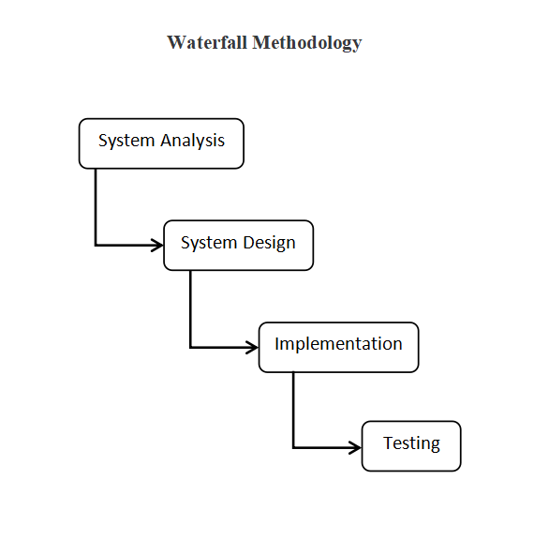

**Figure 4****: Chapter 3 Waterfall Methodology**

First phase of waterfall methodology is System analysis which contains four types i.e, requirement analysis, feasibility analysis, data modeling, process modeling. Requirement analysis has further divided into two part. They are functional and non functional requirement. Feasibility analysis also divided into four part. They are technical, operational, economic and schedule. Second phase is system design which have four design part which shows the project function in the form of figure. They are architectural design, database schema design, Interface design and physical DFD. Third phase is implementation which show the tools that are used in the time of developing the project. It have two part that is tools used and implementation details of modules. Forth phase is testing which is done to check whether the project is working properly as per requirement or not. It also have two parts that is unit testing and system testing.

## 3.1. System Analysis

## 3.1.1. Requirement Analysis

1. Functional Requirements

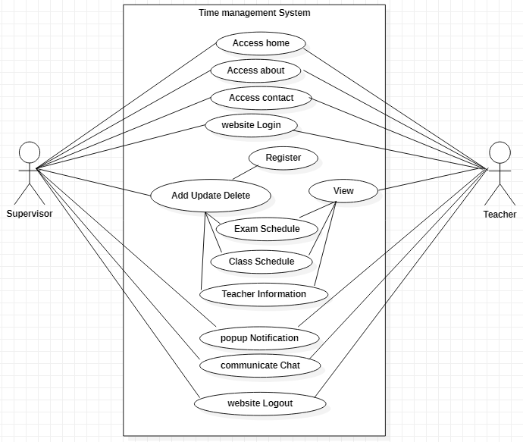

**Figure 5****: Chapter 3.1.1 Use case**

As above Use Case Diagram show the roles of the two persons as an supervisor and Teacher s. supervisor have the authorities to manipulate in the system where Teacher s have only few authority. There are many features like notification, chats, updating, deleting, login, logout system, registration, records of Teacher , class routine, exam routines and can access the system online. These are mostly required to complete the system. Both supervisor and Teacher s can access the front view of the system before login such like home, about, contact and login sites.

1. supervisor can add or delete the Teacher s from the system as members by their email id along with password.
2. When supervisor registered the Teacher s name as member, Teacher have to use their email id and password to login in the system.
3. Whenever supervisor alter in the system, the notifications would be automatically sent to the Teacher s if they are added to the system.
4. Whenever the Teacher s have any problems regards update, they would have chat feature to communicate with supervisor about it.
5. Once the supervisor or Teacher s would be the members, they would have access ability (login) from anywhere but it would requires net.
6. If the supervisor and Teacher would like to leave the system from the connect device they would simply need to logout.

#### Non Functional Requirements

1. Hidden Password

This features makes the system more secure for the supervisor and Teacher s. Through this system the both supervisor and Teacher can hide their password in the time of login and registration.

1. Encrypted password

This features also makes the system more secure by encrypting the password in the form of number and alphabets. Through this system the password are hide their password in the time of login and registration.

This project password are encrypted in the database.

1. Time responsive

It is deals with the time response while opening the websites.

### 3.1.2. Feasibility Analysis

#### Technical

As a technical feasibility, the system is easy to use by every people without having the problems of misunderstanding. It doesn’t required extra or additional knowledge to use it. Its so simple to use and Teacher -friendly. Once you use it, you will have ideal and can easily creates class routine, schedule, exam routine.

#### Operational

As a operational feasibility, Once system is operated through login into it , the supervisor can fully have authorities or ready to used the program. supervisor can add and delete the person along with their id, name, address, email, phone number, etc. supervisor can changes in schedule, routine, class, etc. Once changes is done the message will goes to the those person who are added in the system. Even they can message through this system with each others.

#### Economic

As an economic feasibility, after the complete of system, it will not cost for system. but as to connect to the net and to use world widely . It will cost to active the system and needed Domain to host the system as to access online. Once it run in the electronic devices which access internet. it can be used in both android and laptop, etc.

#### Schedule

Through this, timeline is develop for the project. It makes quite easier to see the tasks along with time required and how long should be taken to complete it. It also shows the who should be working on it and what order work should be done in. The following Gantt Chart shows the timeline and completion of project along with the starting and ending dates of the project.

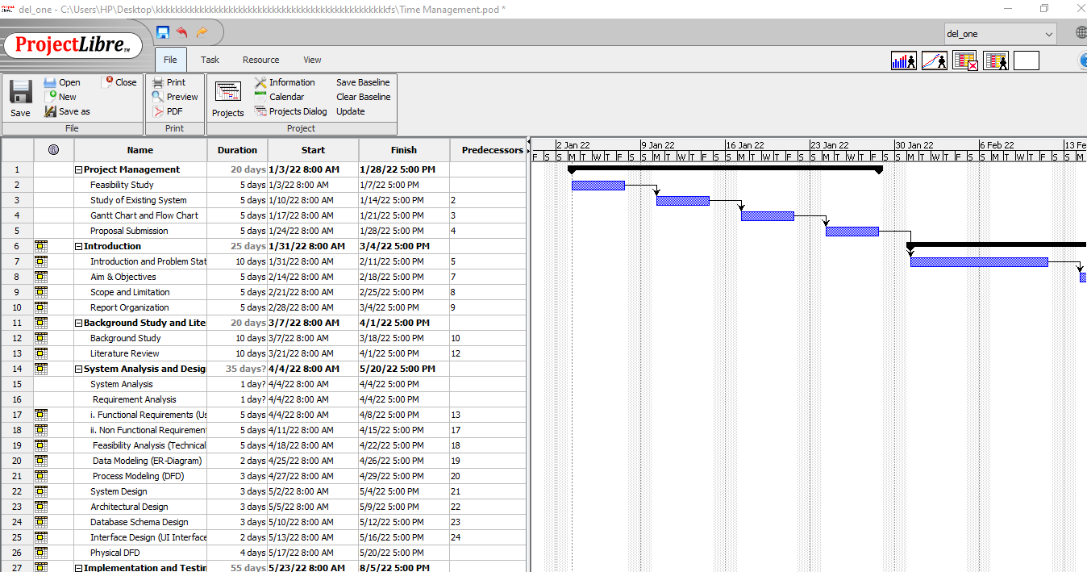

**Figure 6****: Chapter 3.1.2 Schedule_Gantt chart 1**

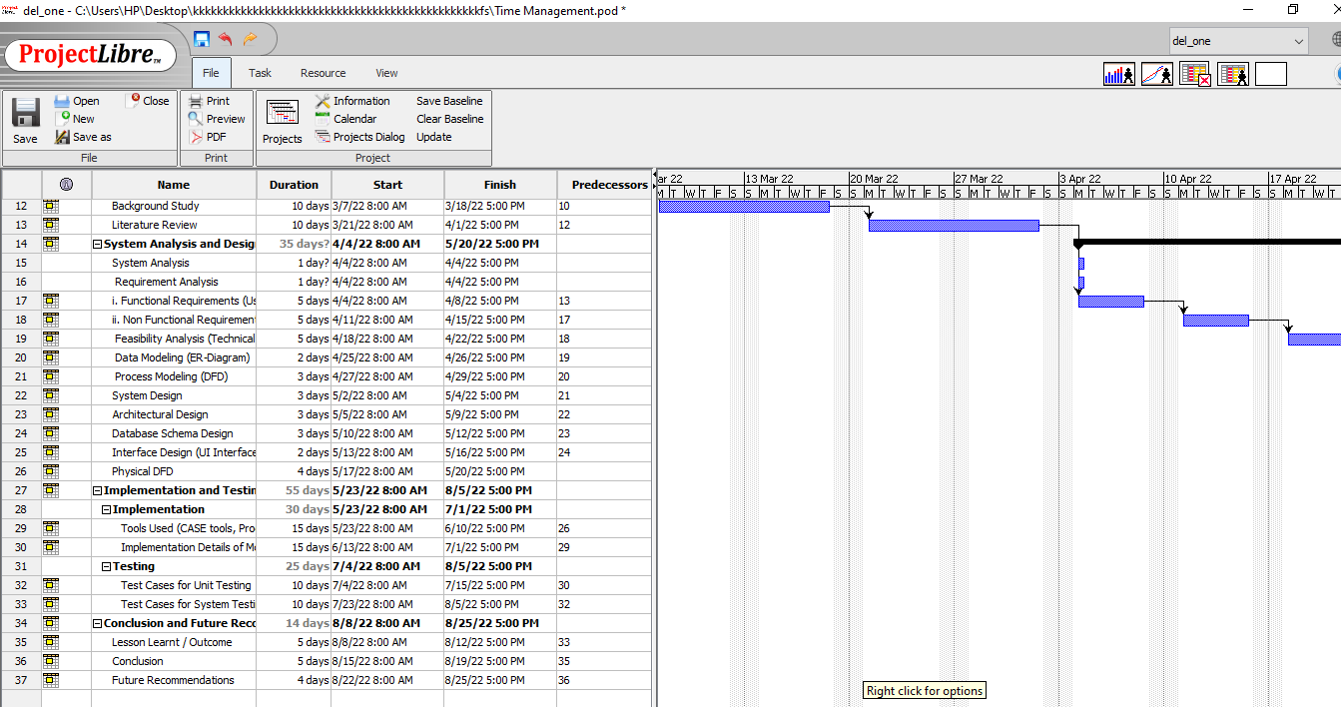

**Figure 7****: Chapter 3.1.2 Schedule_Gantt chart 2**

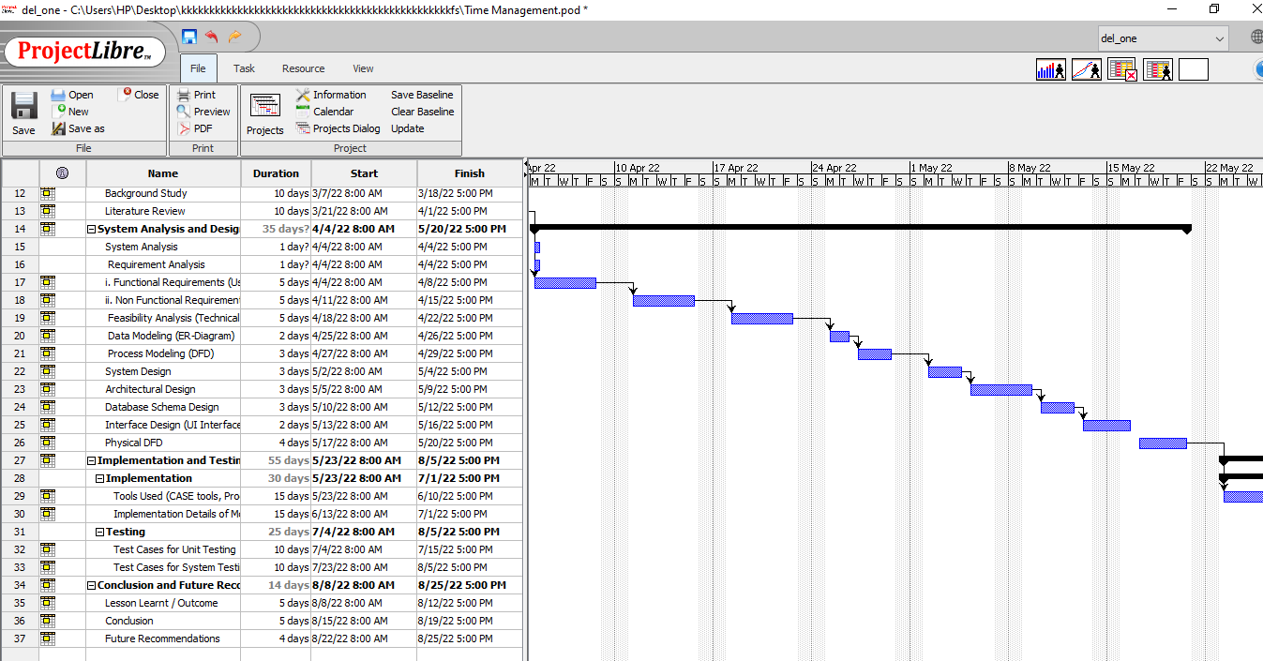

**Figure 8****: Chapter 3.1.2 Schedule_Gantt chart 3**

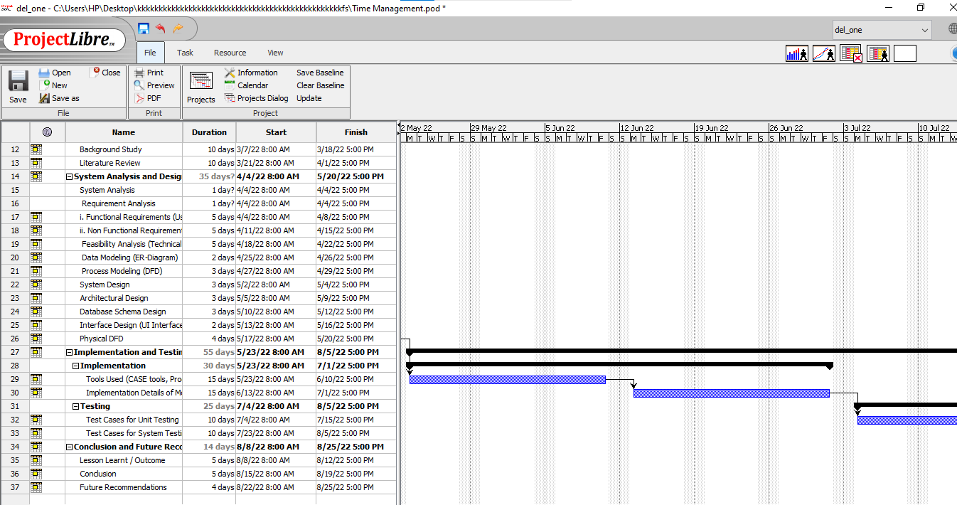

**Figure 9****: Chapter 3.1.2 Schedule_Gantt chart 4**

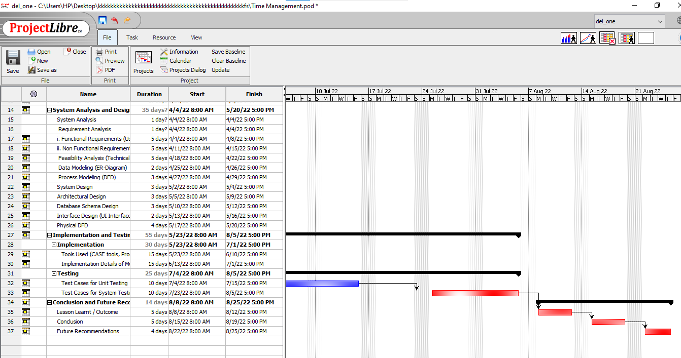

**Figure 10****: Chapter 3.1.2 Schedule_Gantt chart 5**

### 3.1.3. Data Modeling (ER-Diagram)

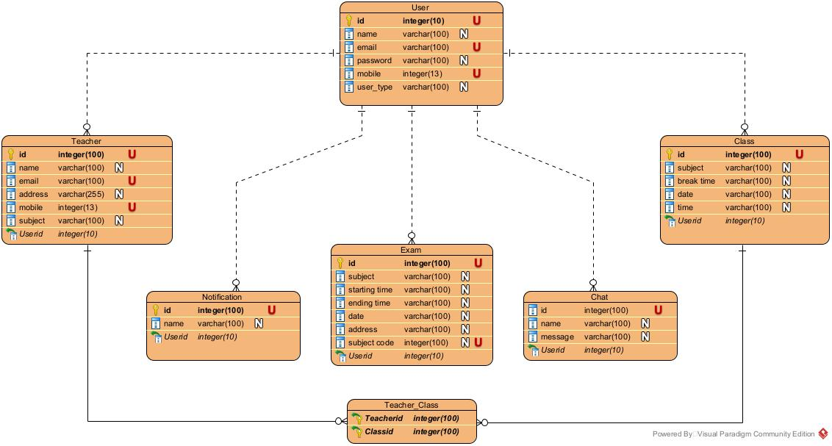

**Figure 11****: Chapter 3.1.3 E-R Diagram**

Above E-R Diagram show the one to many and many to many relationship between the different entity table in the system. There are six entities which includes Teacher s, Teacher , Class, Exam, Course, Notification and Chat. Even we have six entity in the E-R diagram, all are required to complete the system. Teacher s entity contains six attributes i,e id, name, email, password, mobile and Teacher s_type. This Teacher s entity separate the Teacher as register in the system with Teacher _type whether Teacher is supervisor or Teacher s. Teacher entity have four attributes that includes the id, name, email, address, mobile, subject of the Teacher . Class entity have six attributes that are id, subject, break time, date, time of the class period. Exam entity has seven attributes that are id, subject, starting time, ending time, date, address and subject code which shows the exam routine. Chat entity have three attributes that are id, name and message of the chat feature which holds the data in it. Similarly, notification have two entity that are id and name which helps to notify the Teacher s as notification.

**3.1.4. Process Modeling (DFD)**

It represent the system of different levels of abstraction. It have 3 levels. Started from level 0 to level 2. level 0 represent the system as a single process with its relationship to external entities. It shows entire system as a single bubble with inputs and outputs data indicated by arrows. level 1 represent the main functions of the system and breakdown the high-level of level 0 into sub process. Level 2 represent the one step deeper into parts of level 1 with functional and database storage. The following figures shows the level 0, level 1 and level 2 of DFD. [30]

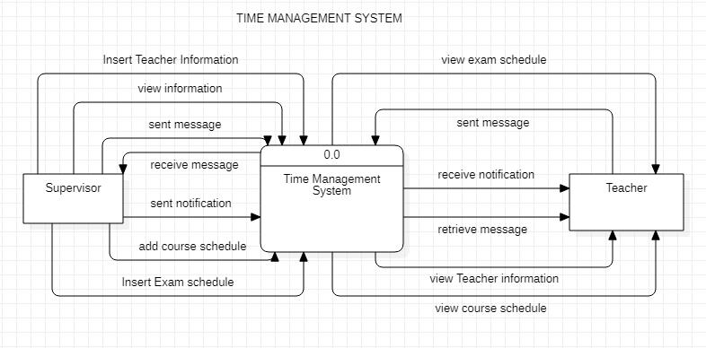

**Figure 12****: Chapter 3.1.4 level 0 DFD**

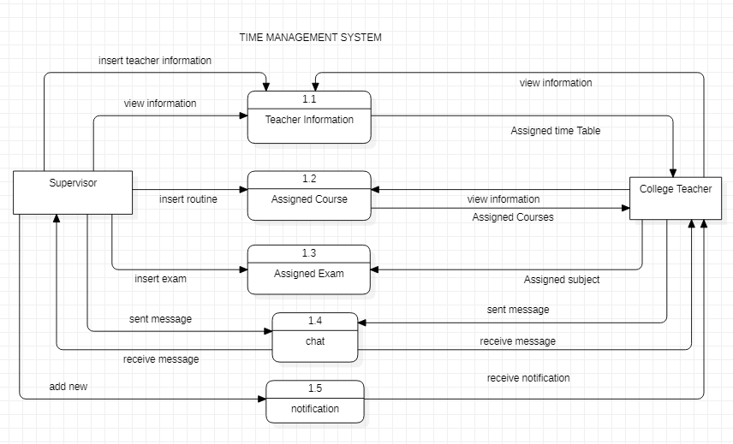

**Figure 13****: Chapter 3.1.4 level 1 DFD**

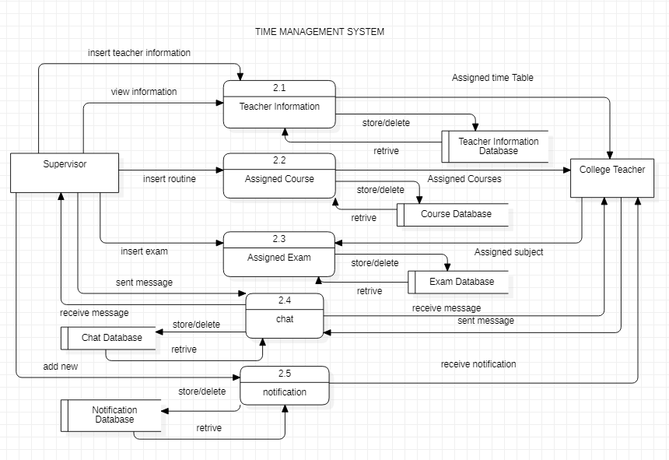

**Figure 14****: Chapter 3.1.4 level 2 DFD**

## 3.2. System Design

### 3.2.1. Architectural Design

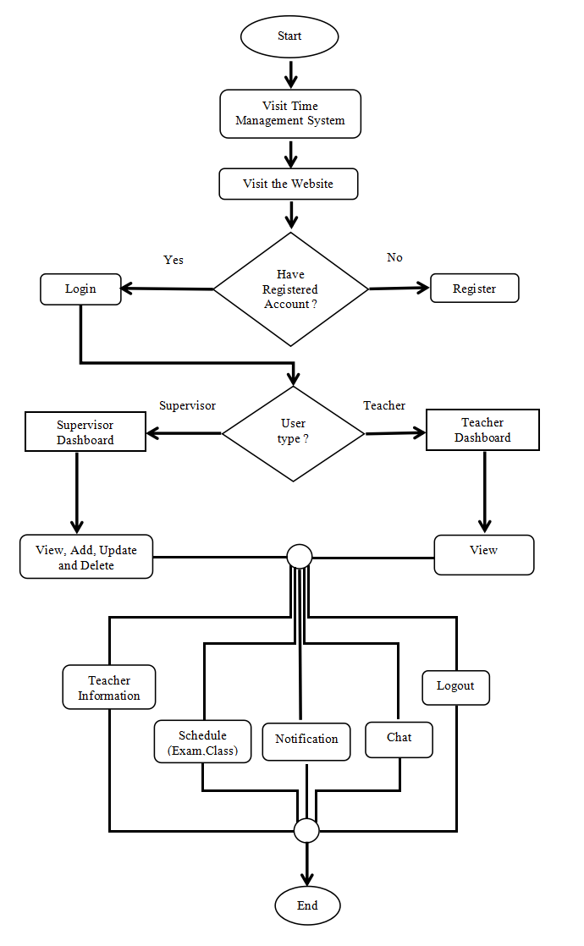

**Figure 15****: Chapter 3.2.1 Flow-chart**

Above flowchart shows the workflow of the system. As anyone enter in the system then he/she have to login first. But for that the account should register in his/her name. If he/she has the account can easily login into the main system. Before that the system analysis whether the login person is supervisor or teacher. When it is determined then dashboard will be freely able to access by the Teacher according the Teacher types. If the person is supervisor then he/she can add, delete, update in the system where teacher can view available information and sent message.

### 3.2.2. Database Schema Design

In this project, the Database is created thought the help of xampp with MySQL.

The main database is named as tms and it have six table name which have its own attributes which is shown in the figure below.

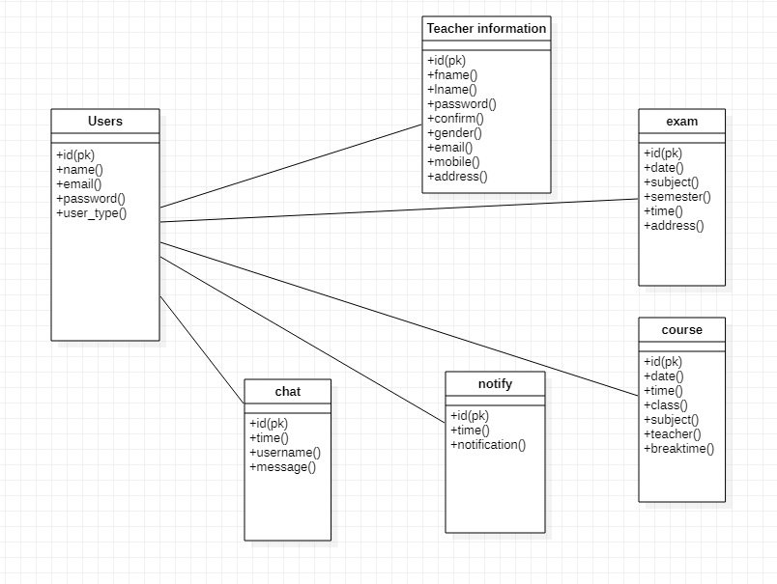

**Figure 16****: Chapter 3.3.2 Database schema**

### 3.2.3. Interface Design (UI Interface / Interface Structure Diagrams)

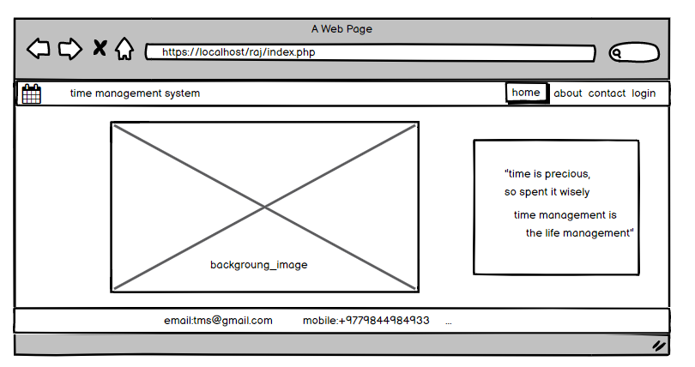

**Figure 17****: Chapter 3.2.3 home page UI**

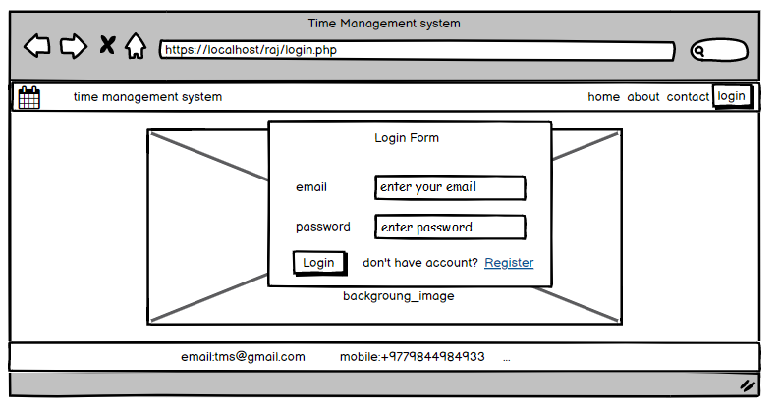

**Figure 18****: Chapter 3.2.3 Login UI**

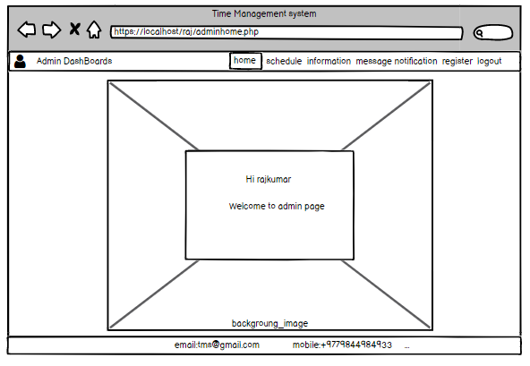

**Figure 19****: Chapter 3.2.3 supervisor page UI**

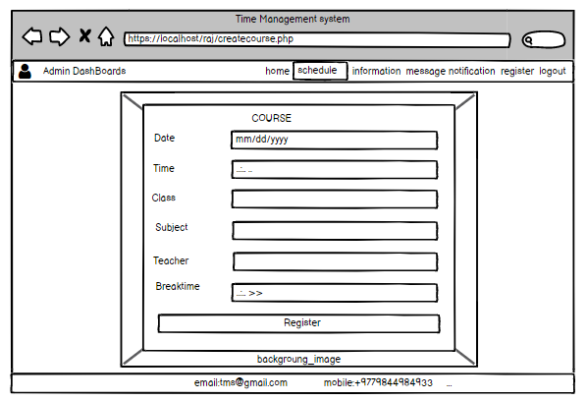

**Figure 20****: Chapter 3.2.3 Schedule UI**

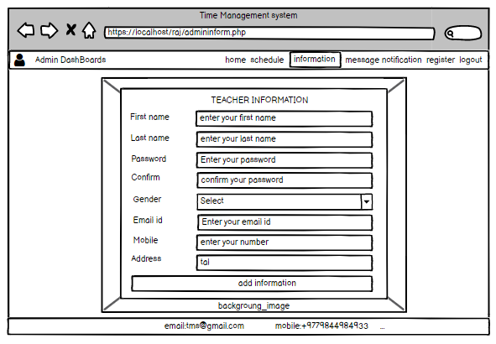

**Figure 21****: Chapter 3.2.3 Information UI**

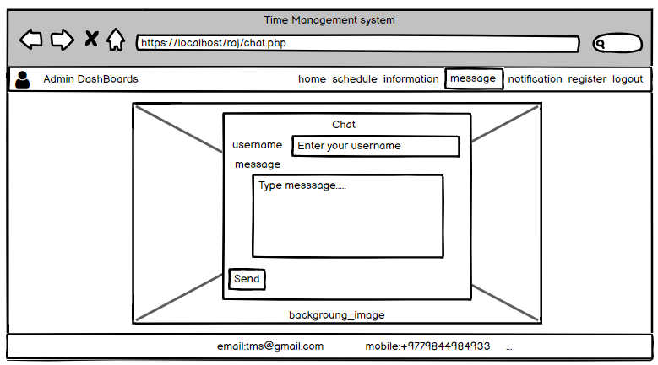

**Figure 22****: Chapter 3.2.3 Message UI**

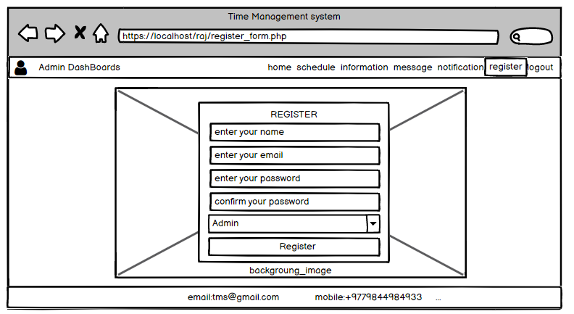

**Figure 23****: Chapter 3.2.3 Register UI**

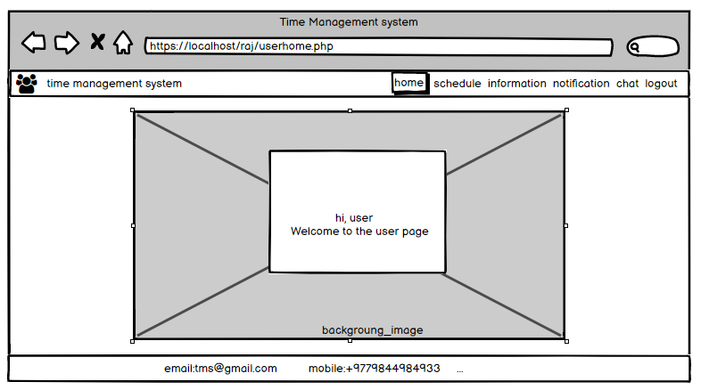

**Figure 24****: Chapter 3.2.3 Teacher page UI**

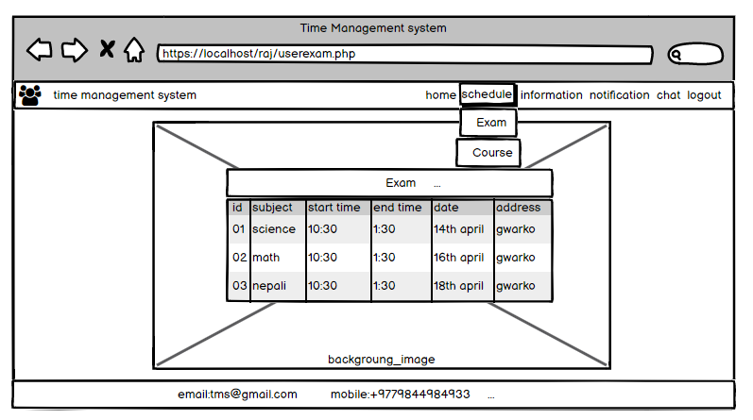

**Figure 25****: Chapter 3.2.3 Teacher Exam UI**

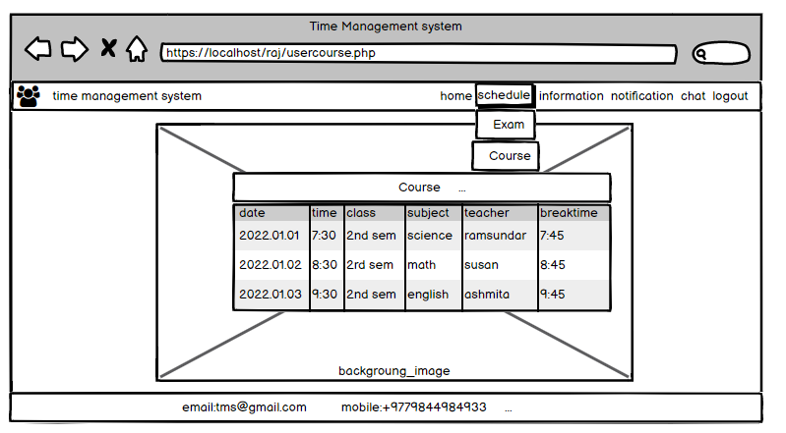

**Figure 26****: Chapter 3.2.3 Teacher Course UI**

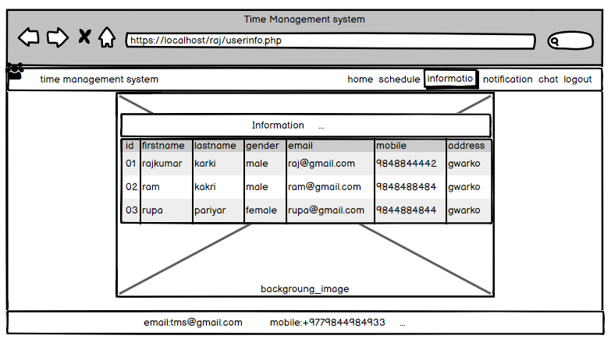

**Figure 27****: Chapter 3.2.3 Teacher Information**

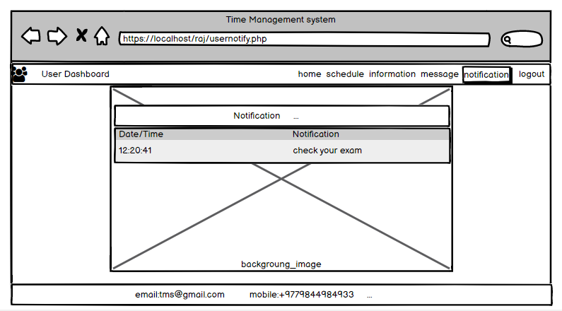

**Figure 28****: Chapter 3.2.3 Teacher Notification UI**

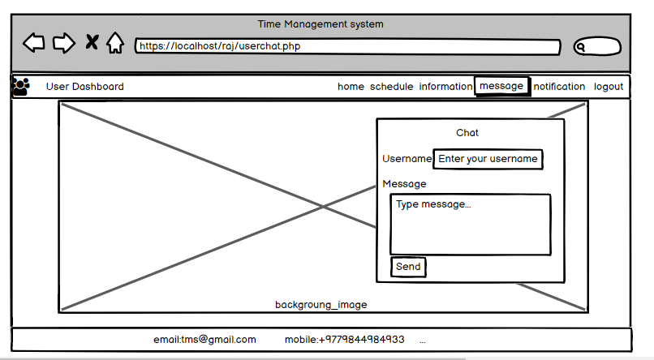

**Figure 29****: Chapter 3.2.3 Teacher Chat UI**

### 3.2.4. Physical DFD

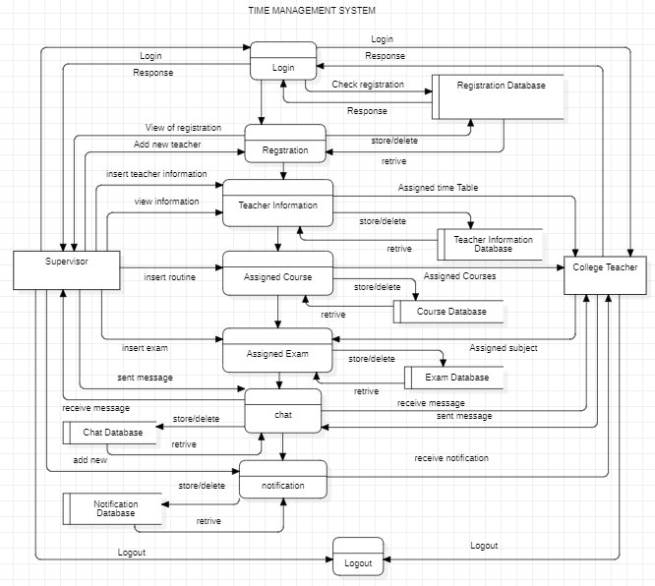

**Figure 30****: Chapter:3.2.4 Physical DFD**

# Chapter 4: Implementation and Testing

## 4.1. Implementation

### 4.1.1. Tools Used (CASE tools, Programming languages, Database platforms)

**CASE Tools**

**Table 2****: Chapter: 4.1.1 CASE tools**

|  |  |
| --- | --- |
| Used for | Tools and technologies |
| Analysis Tools |  |
| Design Tools | balasamiq |
| Programming Tools | sublime |
| Prototyping Tools | balasamiq |
| Maintenance Tools | sublime |
| Diagram Tools |  |
| Process Modeling Tools |  |
| Project Management Tools |  |
| Documentation Tools | wps |
| Configuration Management Tools | wps |
| Change Control Tools |  |
| Web Development Tools | sublime chrome explorer xampp |
| Quality Assurance Tools | wps |

**Storyboard**

The Storyboard Creator is an graphic designing website through which textual form story can be created. It is very easy to use and can be learn through it. To use it, simply you have to drag and drop which is quite interesting and fun to make. It can be use by all ages of people. It have many characters and dialogue box images that helps to display the information of any kind in the form of image and pictures. [12]

**Visual Paradigm**

Visual Paradigm is an application software which is used by the software development teams to model business information systems and manage development processes. Along with modeling support, it also provides facilities of report generation and code engineering capabilities including code generation. [13]

**XMind**

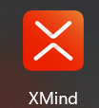XMind is a software developed by XMind Ltd. It is a mind mapping and brainstorming software which is used to capture ideas, clarify thinking, manage complex information and promote team collaboration. It supports mind maps, fishbone diagrams, tree diagrams, organization charts, spreadsheets etc and is used for knowledge management, meeting minutes and task management. [14]

**StarUML**

StarUML is a modular and open tool which provides frameworks for extending the functionality of the tools. It allows to access to all functions of the model/ meta- model and tool through COM Automation and provides extension of menu and option items. It allows Teacher s to create to their own approaches and frameworks according to their methodologies. Any external tools can be integrated with this tool. [15]

**Sublime**

Sublime Text is a shareware cross-platform source code editor which support many programming and markup languages. Using plugins, Teacher can expand its functionality. To provide plugins feature, Sublime Text features a Python API. [16]

**ProjectLibre**

ProjectLibre is the project management tools which is used to complete project details including time periods as required. In another terms, it can be said that it helps to create the time line and deadlines of the project. This tool helps to show the needed or required time to complete the project. [17]

**Balasamiq cloud**

Balasamiq Cloud is a web-based Teacher interface design tool mostly used for creating wireframes. It is used to generate digital sketches of an idea or concept for an application or website, to facilitate discussion and understanding before writing any code. The completed wireframes are used for Teacher testing, clarifying vision, and getting feedback from stakeholder as well as for getting approval to start development. [18]

**WPS Office**

WPS Office is a free office software which involve Writes, Spreadsheet, Presentation and PDF. It provides ideal working experience for devices like PC, pad and phone. It allows to achieve high work efficiency anytime and anywhere. [19]

**YouTube**

YouTube is a video sharing social media platform where any Teacher s can watch, like, share, comment and upload their own videos. YouTube can be accessed through PC, laptops, tablets and mobile phones. [20]

**Google Chrome**

Google Chrome is a web browser developed by Google. It is used for displaying the contents of the web pages available on the internet. It was development to replace the Internet Explorer. It contains a new rendering engine, provides annotation features, easy to use icons and allows the Teacher to draw on Web pages. This browser also provides the features of betters security and better organization. It can also integrate with Cortana, Microsoft's virtual personal assistant. [21]

**Microsoft Edge**

Originally, it is the replacement of Internet Explorer. Since 1995, it was default browser in that time of windows system. It requires 1 GB of memory. It has a new rendering engine along with annotation features. it’s allows Teacher s to draw on Web pages with easy to use icons features. As comparing with internet explorer, it has better security. [22]

**Mysqli**

The MySQLi Extension ([MySQL](https://en.wikipedia.org/wiki/MySQL" \o "MySQL) Improved) is a [relational database](https://en.wikipedia.org/wiki/Relational_database" \o "Relational database) driver used in the [PHP](https://en.wikipedia.org/wiki/PHP" \o "PHP) [scripting language](https://en.wikipedia.org/wiki/Scripting_language" \o "Scripting language) to provide an interface with [MySQL](https://en.wikipedia.org/wiki/MySQL" \o "MySQL) [databases](https://en.wikipedia.org/wiki/Database" \o "). The MySQLi extension features a dual interface - it supports both the procedural and object-oriented programming paradigms.

The MySQL server supports the use of different transport layers for connections. Connections use TCP/IP, Unix domain sockets or Windows named pipes. The hostname localhost has a special meaning. It is bound to the use of Unix domain sockets. It is not possible to open a TCP/IP connection using the hostname localhost you must use 127.0.0.1 instead.

Statements can be executed with the mysqli_query(), mysqli_real_query() and mysqli_multi_query() functions. [29]

**XAMPP**

XAMPP is a cross-platform web server that is free and open-source. XAMPP is a short form for Cross-Platform, Apache, MySQL, PHP, and Perl. XAMPP is a popular cross-platform web server that allows programmers to write and test their code on a local web server. It was created by Apache Friends, and the public can revise or modify its native source code. It includes MariaDB, Apache HTTP Server, and interpreters for PHP and Perl, among other computer languages. [31]

**Programming Languages**

**Table 3****: Chapter: 4.1.1 Programming tools**

|  |  |
| --- | --- |
| Used for | Tools and technologies |
| Programming languages |  |

**HTML**

The HyperText Markup Language or HTML is the standard [markup language](https://en.wikipedia.org/wiki/Markup_language" \o "Markup language) for documents designed to be displayed in a [web browser](https://en.wikipedia.org/wiki/Web_browser" \o "Web browser). It can be assisted by technologies such as [Cascading Style Sheets](https://en.wikipedia.org/wiki/Cascading_Style_Sheets" \o "Cascading Style Sheets) (CSS) and [scripting languages](https://en.wikipedia.org/wiki/Scripting_language" \o "Scripting language) such as [JavaScript](https://en.wikipedia.org/wiki/JavaScript" \o "JavaScript).

[Web browsers](https://en.wikipedia.org/wiki/Web_browser" \o "Web browser) receive HTML documents from a [web server](https://en.wikipedia.org/wiki/Web_server" \o "Web server) or from local storage and [render](https://en.wikipedia.org/wiki/Browser_engine" \o "Browser engine) the documents into multimedia web pages. HTML describes the structure of a [web page](https://en.wikipedia.org/wiki/Web_page" \o "Web page) [semantically](https://en.wikipedia.org/wiki/Semantic_Web" \o "Semantic Web) and originally included cues for the appearance of the document. [23]

**JavaScript**

JavaScript is a dynamic programming language that's used for web development, in web applications, for game development, and lots more. It allows you to implement dynamic features on web pages that cannot be done with only HTML and CSS.

Many browsers use JavaScript as a scripting language for doing dynamic things on the web. Any time you see a click-to-show dropdown menu, extra content added to a page, and dynamically changing element colors on a page, to name a few features, you're seeing the effects of JavaScript. [24]

**CSS**

Cascading Style Sheets (CSS) is a [style sheet language](https://en.wikipedia.org/wiki/Style_sheet_language" \o "Style sheet language) used for describing the [presentation](https://en.wikipedia.org/wiki/Presentation_semantics" \o "Presentation semantics) of a document written in a [markup language](https://en.wikipedia.org/wiki/Markup_language" \o "Markup language) such as [HTML](https://en.wikipedia.org/wiki/HTML" \o "HTML).CSS is a cornerstone technology of the [World Wide Web](https://en.wikipedia.org/wiki/World_Wide_Web" \o "World Wide Web), alongside HTML and [JavaScript](https://en.wikipedia.org/wiki/JavaScript" \o "JavaScript).

CSS is designed to enable the separation of presentation and content, including [layout](https://en.wikipedia.org/wiki/Page_layout" \o "Page layout), [colors](https://en.wikipedia.org/wiki/Color" \o "Color), and [fonts](https://en.wikipedia.org/wiki/Typeface" \o "Typeface). This separation can improve content [accessibility](https://en.wikipedia.org/wiki/Accessibility" \o "Accessibility); provide more flexibility and control in the specification of presentation characteristics; enable multiple [web pages](https://en.wikipedia.org/wiki/Web_page" \o "Web page) to share formatting by specifying the relevant CSS in a separate. [25]

**PHP**

PHP is a [general-purpose](https://en.wikipedia.org/wiki/General-purpose_programming_language" \o "General-purpose programming language) [scripting language](https://en.wikipedia.org/wiki/Scripting_language" \o "Scripting language) geared toward [web development](https://en.wikipedia.org/wiki/Web_development" \o "Web development).PHP originally stood for Personal Home Page, but it now stands for the [recursive initialism](https://en.wikipedia.org/wiki/Recursive_initialism" \o "Recursive initialism) PHP: Hypertext Preprocessor.

PHP code is usually processed on a [web server](https://en.wikipedia.org/wiki/Web_server" \o "Web server) by a PHP [interpreter](https://en.wikipedia.org/wiki/Interpreter_(computing)" \o "Interpreter (computing)) implemented as a [module](https://en.wikipedia.org/wiki/Plugin_(computing)" \o "Plugin (computing)), a [daemon](https://en.wikipedia.org/wiki/Daemon_(computing)" \o "Daemon (computing)) or as a [Common Gateway Interface](https://en.wikipedia.org/wiki/Common_Gateway_Interface" \o "Common Gateway Interface) (CGI) executable. On a web server, the result of the [interpreted](https://en.wikipedia.org/wiki/Interpreter_(computing)" \o "Interpreter (computing)) and executed PHP code – which may be any type of data, such as generated [HTML](https://en.wikipedia.org/wiki/HTML" \o "HTML) or [binary](https://en.wikipedia.org/wiki/Binary_number" \o "Binary number) image data – would form the whole or part of an [HTTP](https://en.wikipedia.org/wiki/Hypertext_Transfer_Protocol" \o "Hypertext Transfer Protocol) response. [26]

**Ajax**

AJAX stands for Asynchronous JavaScript and XML. AJAX is a new technique for creating better, faster, and more interactive web applications with the help of XML, HTML, CSS, and Java Script. Ajax uses XHTML for content, CSS for presentation, along with Document Object Model and JavaScript for dynamic content display.

It uses various web technologies on the [client-side](https://en.wikipedia.org/wiki/Client-side" \o "Client-side) to create asynchronous [web applications](https://en.wikipedia.org/wiki/Web_application" \o "Web application). With Ajax, web applications can send and retrieve data from a [server](https://en.wikipedia.org/wiki/Web_server" \o "Web server) asynchronously (in the background) without interfering with the display and behaviour of the existing page. [27]

**JQuery**

Query is a [JavaScript library](https://en.wikipedia.org/wiki/JavaScript_library" \o "JavaScript library) designed to simplify [HTML](https://en.wikipedia.org/wiki/HTML" \o "HTML) [DOM](https://en.wikipedia.org/wiki/Document_Object_Model" \o "Document Object Model) tree traversal and manipulation, as well as [event handling](https://en.wikipedia.org/wiki/Event_handling" \o "Event handling), [CSS animation](https://en.wikipedia.org/wiki/CSS_animation" \o "CSS animation), and [Ajax](https://en.wikipedia.org/wiki/Ajax_(programming)" \o "Ajax (programming)).jQuery's syntax is designed to make it easier to navigate a document, select [DOM](https://en.wikipedia.org/wiki/Document_Object_Model" \o "Document Object Model) elements, create [animations](https://en.wikipedia.org/wiki/Animation" \o "Animation), handle [events](https://en.wikipedia.org/wiki/Event_(computing)" \o "Event (computing)), and develop [Ajax](https://en.wikipedia.org/wiki/Ajax_(programming)" \o "Ajax (programming)) applications. jQuery also provides capabilities for developers to create [plug-ins](https://en.wikipedia.org/wiki/Plug-in_(computing)" \o "Plug-in (computing)) on top of the JavaScript library. This enables developers to create [abstractions](https://en.wikipedia.org/wiki/Abstraction_(computer_science)" \o "Abstraction (computer science)) for low-level interaction and animation, advanced effects and high-level, theme-able widgets. [28]

### 4.1.2. Implementation Details of Modules (Description of procedures/functions)

**supervisor module**

supervisor is the main person who the full authorities and rights to access the website. So supervisor have many features on websites like registering the name of the Teacher , adding new schedule, new courses and time duration and deleting, update and view.

Login

Login feature allow supervisor to authenticate person who would have the power of controlling the system . Login features allows supervisor to enter into the system if he/she is the supervisor of the system.

Register

Register feature allow supervisor to register the Teacher by their name along with emails. Register feature, registered Teacher can enter into the system which allows Teacher s to be part of the system.

Addition

Addition features allows supervisor to add anything in the system. supervisor can add Teacher as the member of the system, adding new schedule, duration of time, course division and Teacher ’s information.

Deletion

Deletion features allows the supervisor to delete anything from the system if it is not needed anymore. This allows to remove Teacher from being member of system, deleting the schedule, details of Teacher s.

Update

Update features allows supervisor to change in the Teacher ’s email, schedule, duration of time and course division,etc if it is needed. Sometimes data entry in the system might occurs mistake. At that time edit is must needed to correct it.

View

View features allows supervisor to view the supervisor dashboard only but can do some activities that Teacher can’t do. supervisor can view the register list of the Teacher s along with data.

**Teacher s module**

Teacher are the member of the system who are added by admin. supervisor register their name, id and their password as the key to login in the system. Teacher also have some features like login into the system with their Id and password, view the content of the scheduling, course and time duration and can communicate with supervisor with chat feature.

Login

The system has login features for Teacher . Login features allows Teacher to enter in the system if their name is register in the system.

View

View features allow Teacher to see only Teacher dashboard. Teacher can view every schedule, information of Teacher and exam routine done by the admin.

Notification

Notification features allow Teacher to notify about change or anything that happens in the system.

Chatting Module

Both supervisor and Teacher has chatting features to communicate. Whenever both have any problems on schedule, they simple can chat with admin.

## 4.2. Testing

### 4.2.1. Test Cases for Unit Testing

**Table 4****: Chapter 4.2.1 Unit testing**

|  |  |  |  |  |  |  |
| --- | --- | --- | --- | --- | --- | --- |
| S.No | Action | Inputs | Expected Output | Actual Output | Test Result | Test Comment |
| 1. | Add button | On click Add button | Inserted new data | Inserted new data | Pass | Inserted successful |
| 2. | Update button | On click update button | Update existing data | Update existing data | Pass | Updated successful |
| 3. | Delete button | On Click Delete button | Delete exist data | Deleted  Existing data successful | Pass | Deleted successful |
| 4. | View button | On click Display button | Display the details of existing data | Successful  Displaying the data | Pass | View Successful |
| 5. | Chat button | click on Chat button with message | Sent message to Teacher s | Message sent | Pass | Message sent successful |
| 6. | Notify button | Click on notify with message | Notification is sent | Notification sent | pass | Notification sent Successful |
| 7. | Logout button | On click Logout button | Logout from the system | logout  From the system | Pass | logout successful |

### 4.2.2. Test Cases for System Testing

**Table 5****: Chapter 4.2.1 System testing**

|  |  |  |  |  |  |  |
| --- | --- | --- | --- | --- | --- | --- |
| S.No | Action | Input | Expected Output | Actual Output | Test Result | Test Comment |
| 1. | Launch TMS System | https:/localhost/raj/index.php | TMS home | TMS home | Pass | Launch Successful |
| 2. | Login with valid email and password | email Id:raj400@gmail.com  Password: *** | Login Successful | Login Successful | Pass | Login successful |
| 3. | Login with invalid email and valid password | email Id:raj456@gmail.com  Password: *** | Incorrect password and email | Incorrect password and email | Pass | Fail to login |
| 4. | Login with valid email and invalid password | email Id:raj400@gmail.com  Password: ***** | Incorrect password and email | Incorrect password and email | Pass | Fail to login |
| 5. | Login with invalid email and password | email Id:raj456@gmail.com  Password: ********* | Incorrect password and email | Incorrect password and email | Pass | Fail to login |

# Chapter 5: Conclusion and Future Recommendations

## 5.1. Lesson Learn / Outcome

This is my first project so I didn’t have knowledge and idea to develop the website. Even I was confuse in which topic I should develop the website. My Teacher gave me some idea to select the topic. So, I chose college based time management system. Although I got the topic I was still unknown from where to start and where to end the project. So I started searching what kind of time management will be good for the college. I thought about the Teacher and coordinator to generate good relationship and time table schedule between them through online based system. Where there will be Teacher information, course routine and exam routine along with notification and chat functions. And I started coding and documentation where again I faced many problems with it too. I had only little knowledge about the programming language with the help of my subject Teacher (scripting languages). I have learned PHP, JavaScript, Ajax, MySQL and WordPress but to run them combining the code is so difficult and I didn’t have idea. But with the help of Ujjwal sir, he guided me. I got knowledge and idea from w3school where the code is explained properly. And even through YouTube channel like Mr.web designer and Cyber warriors who explained more clearly. In the same way I also tried to execute the code in my own laptop and in the first tired I was successful to develop first home page with HTML and CSS. But as I started coding for login and registration, it required the database to store the registered data. So I have to download XAMPP as to run MYSQL and I have to create database with connection to website as to retrieve the data from database as for login. For three times I was fail to develop the websites because I couldn’t find out the main error. But at the 4th time, my Teacher guided me to find out the error, why errors occurs and how to solve it. When I developed website and wanted to change in it, I got one great idea in the google with the right click of mouse. It gives us Inspects features through which we can see the one by one changes in the website with out disturbing the real code. This was best step for me to learn as a beginner. This is how I completed my project. Through this project I have gain many idea and knowledge about the coding and documentation. I learned about XAMPP, PHP, java Script, HTML, CSS and MYSQL with combining execution and dealing with errors and solving it.

What I have learn was only in theoretical but this project really help me to achieve real time experiences and to develop executable system.

## 5.2. Conclusion

Finally, I have completed my project meeting all the guidance and requirements of TU. My project was on college based time management system which have many features are includes like Teacher ’s information, exam routine, course schedule, registration, chat and notification. And it the demo type website system which manages the schedule within the academic fields. But as looking around in Nepal, everyone is not properly using the time and somehow in Nepal, every work is not completed on time and having habituate of late being. So I want to develop this system with many features which can be useful in any fields and can bring well systematic change in Nepal and Nepali Societies. So it is the first step for me to learn that I’m able to develop the demo type websites.

## 5.3. Future Recommendations

My project is completed with sweet and simple concept. But I want to develop it totally online server based system in the upcoming future which will be require host account like domain. I will develop it fully functional web server along with having several features like accurate time table, calenders feature, meeting scheduling, minuting features, managing time table for students. The system will be not only for Teacher but it will be for students too. My system would be easy to use in any fields like education, business, etc. The system would be compatible with any electronic devices like android mobiles, tablets, computers, etc.

# Appendices

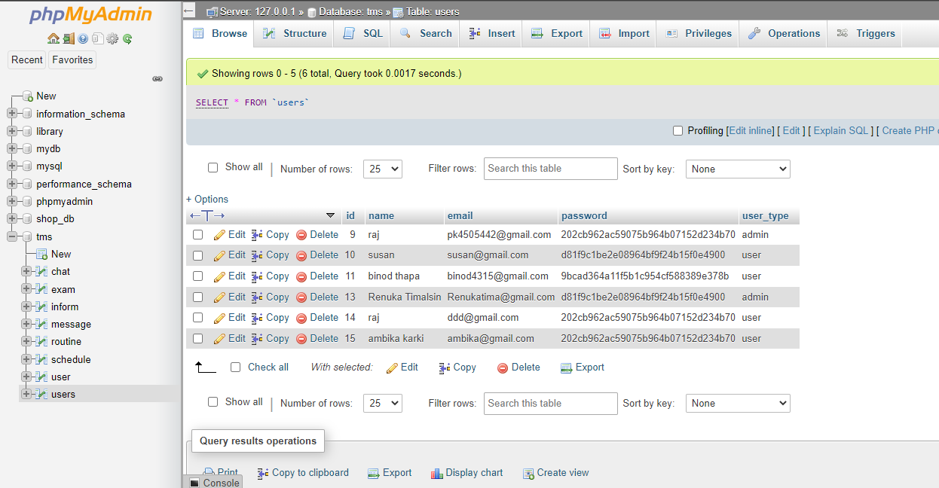

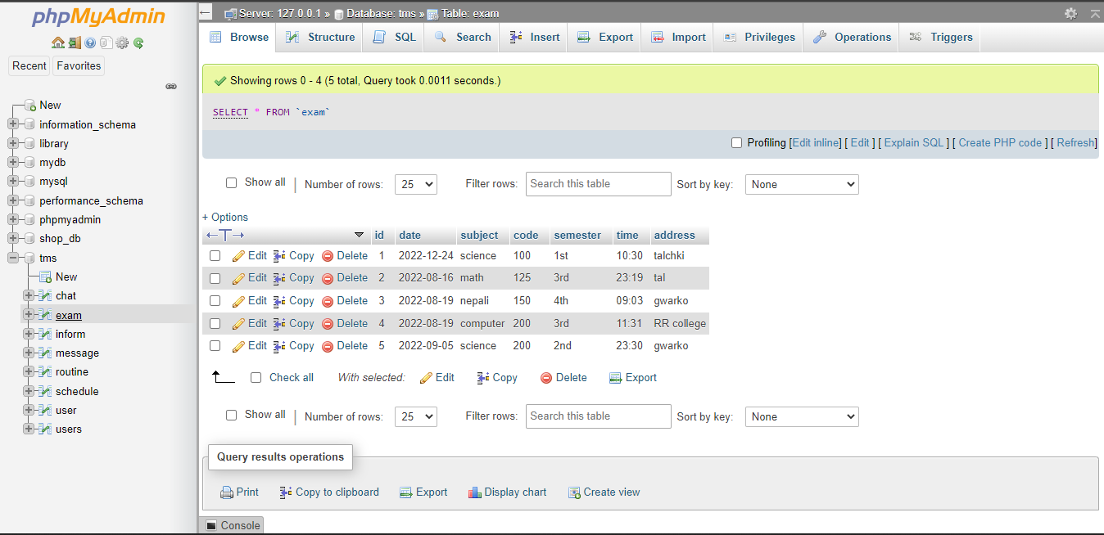

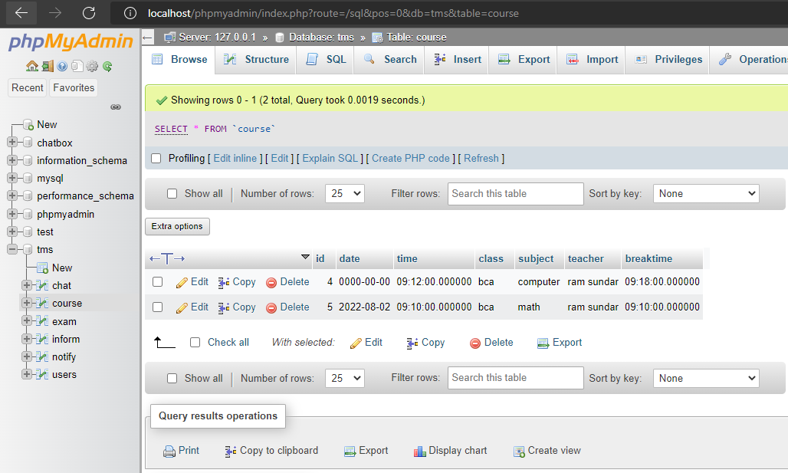

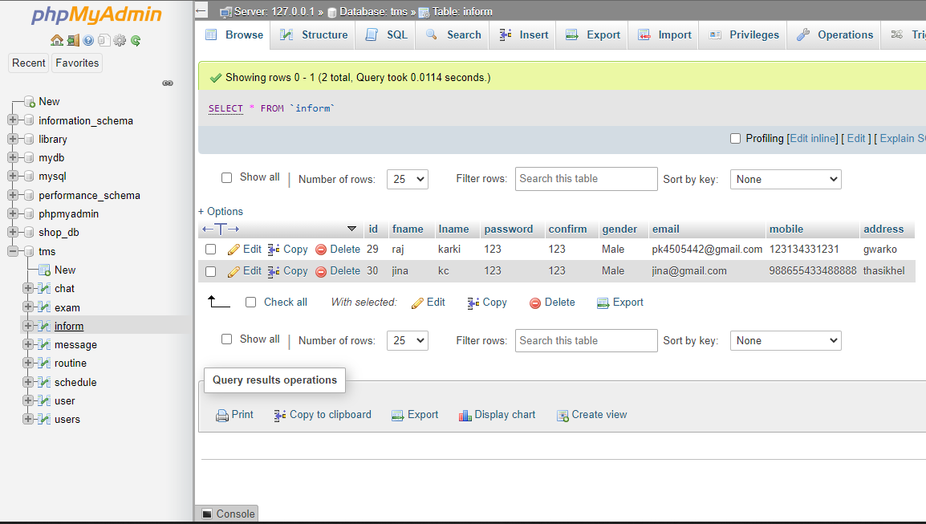

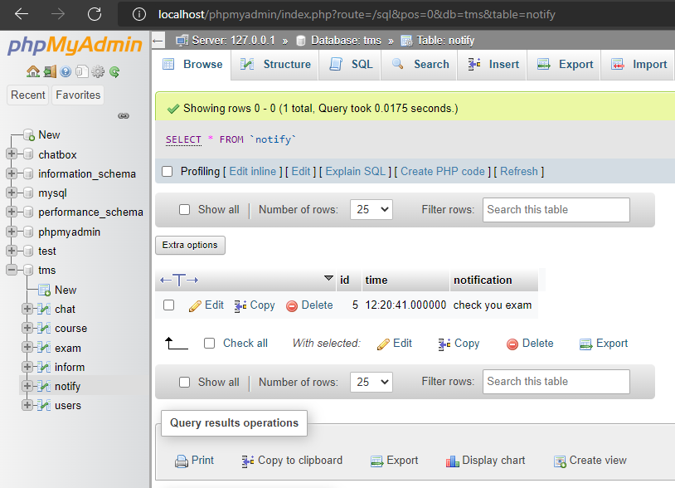

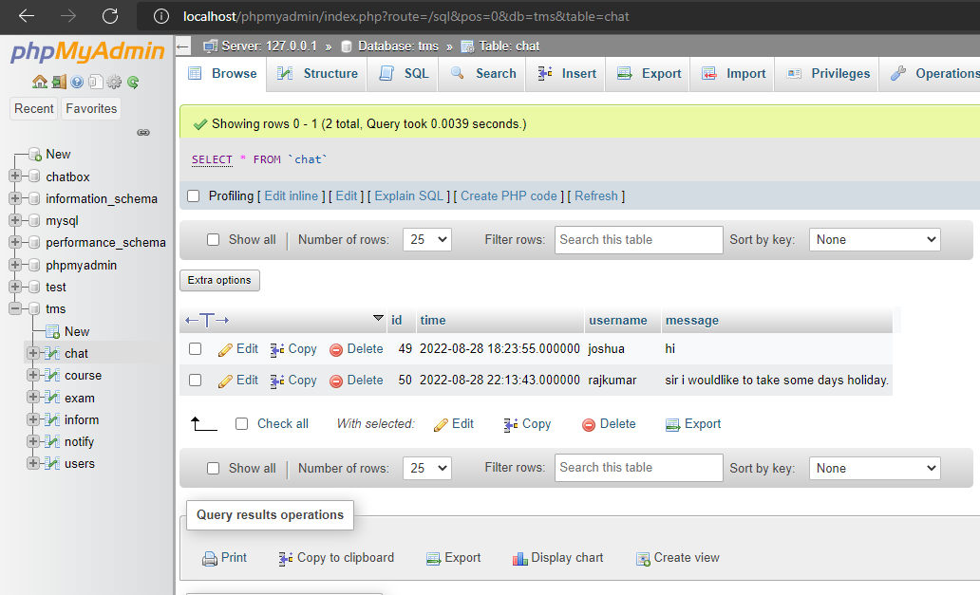

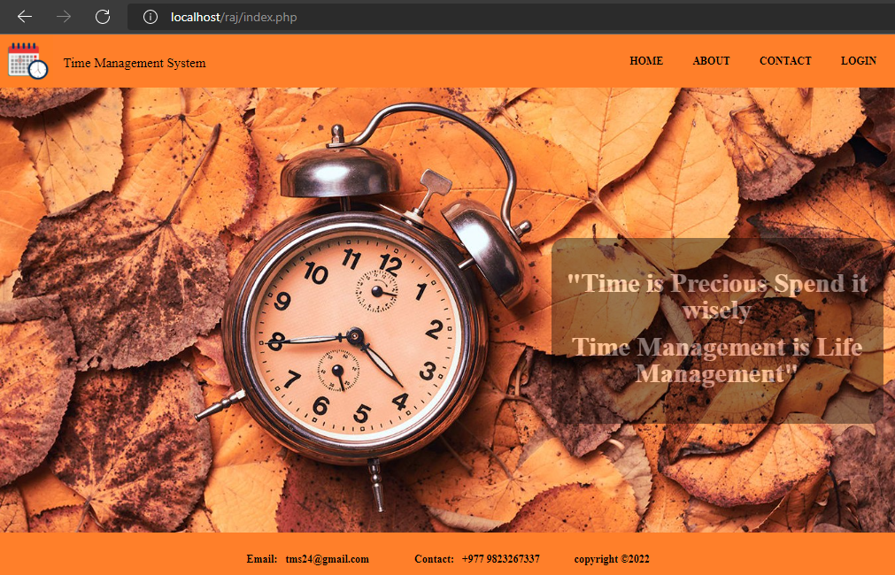

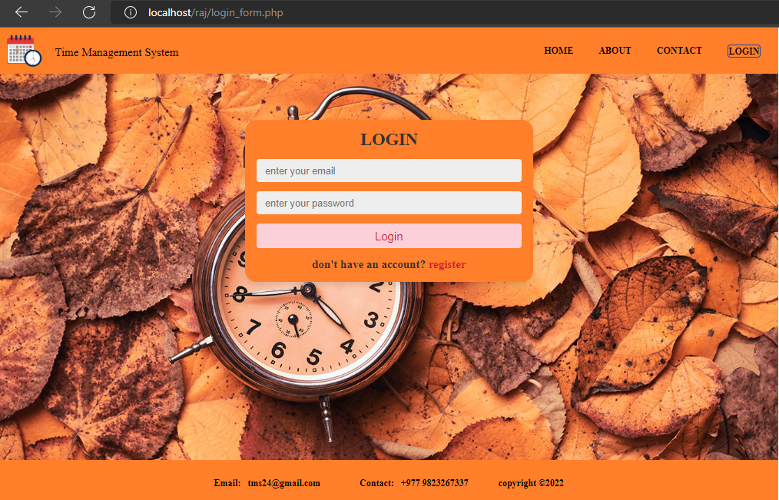

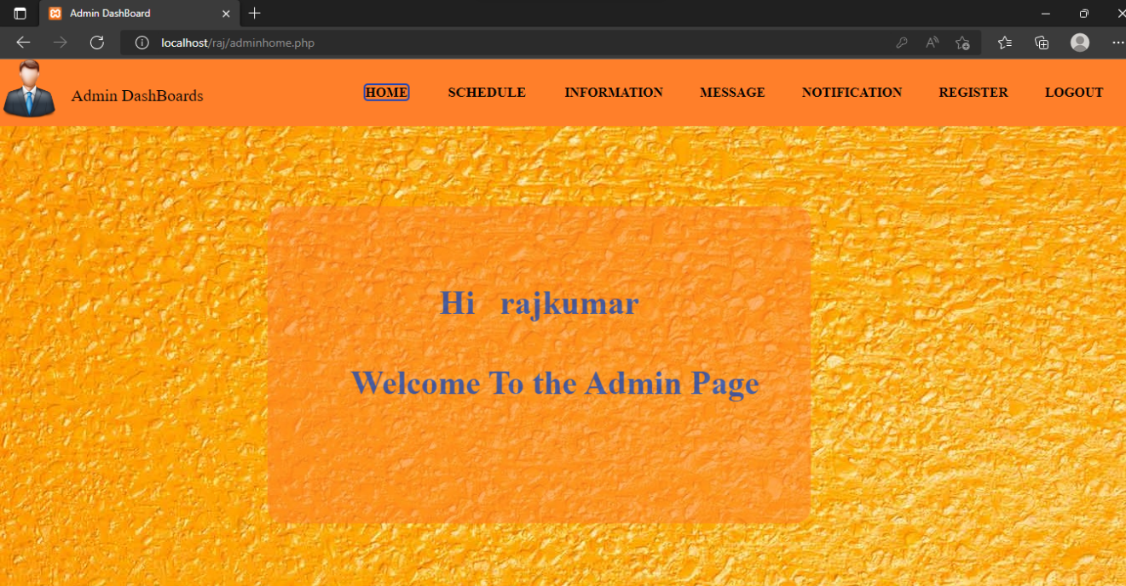

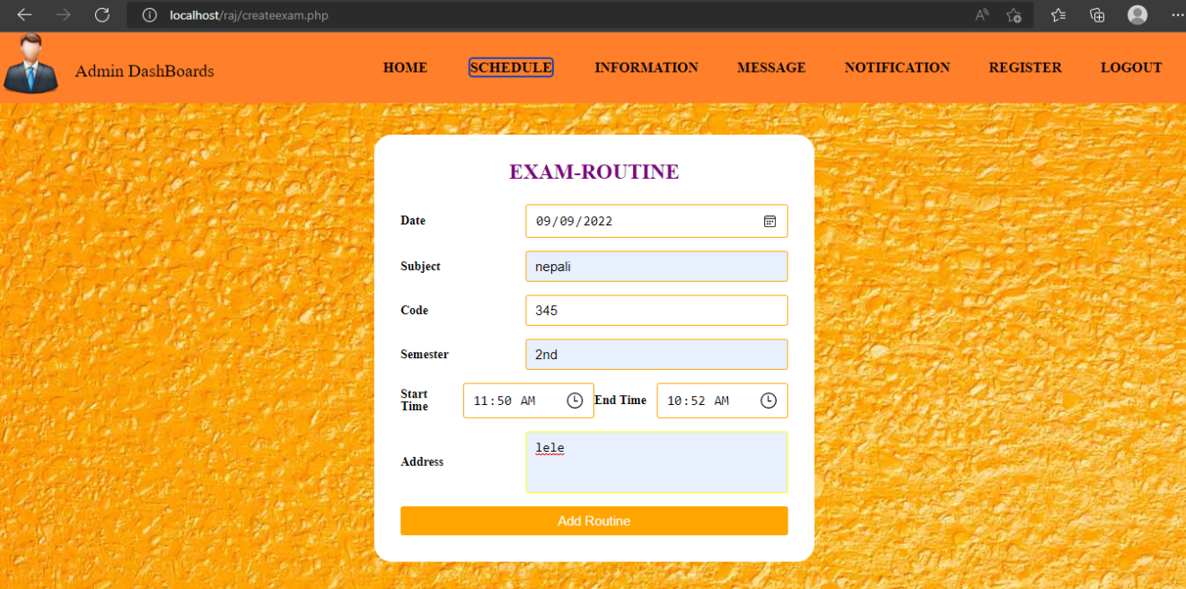

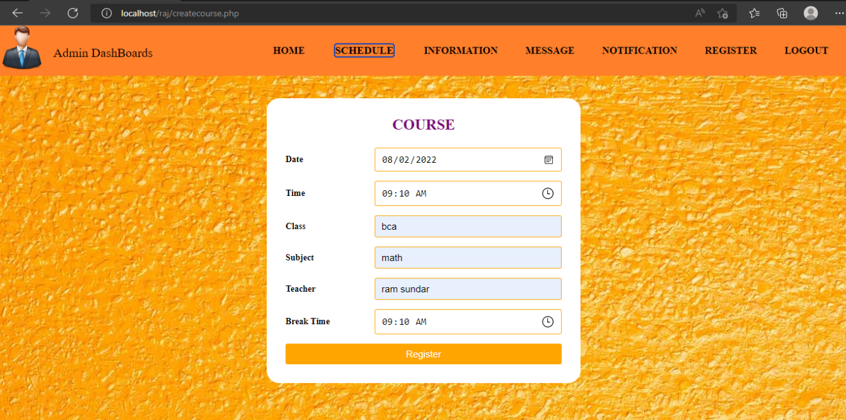

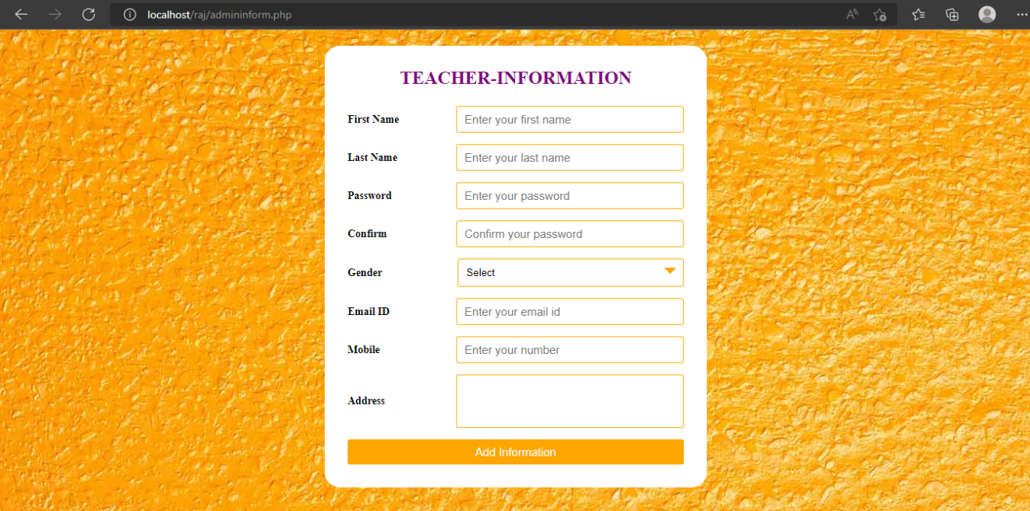

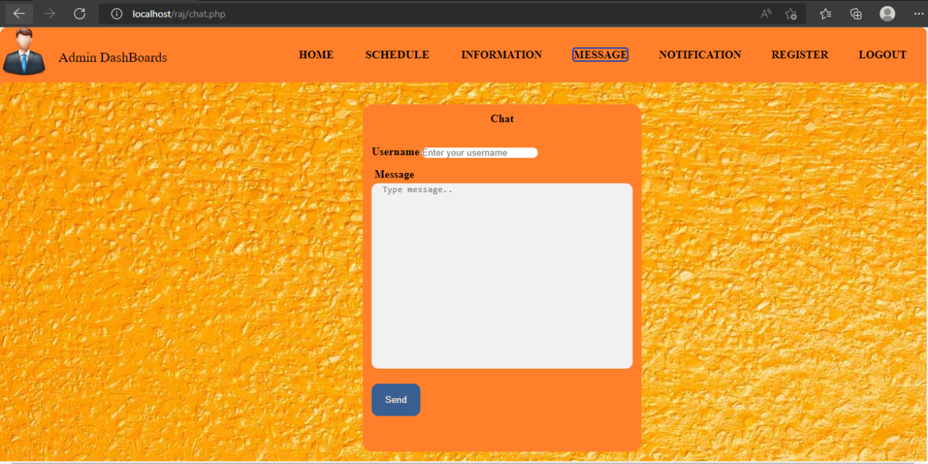

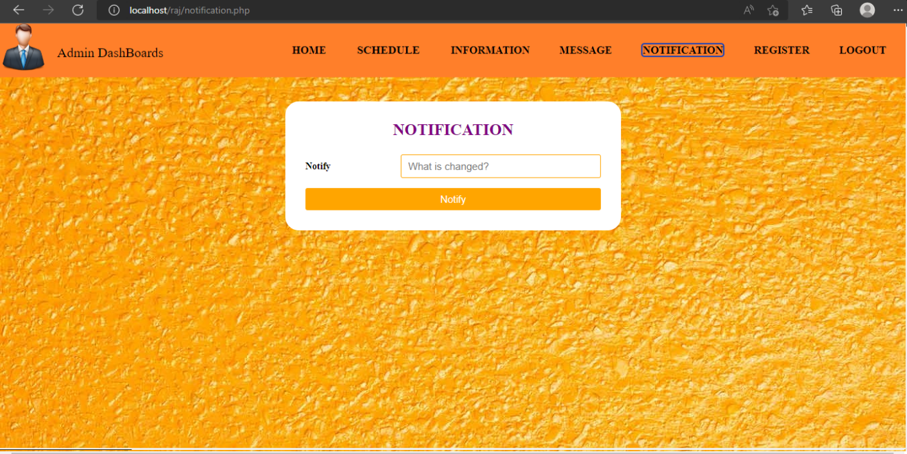

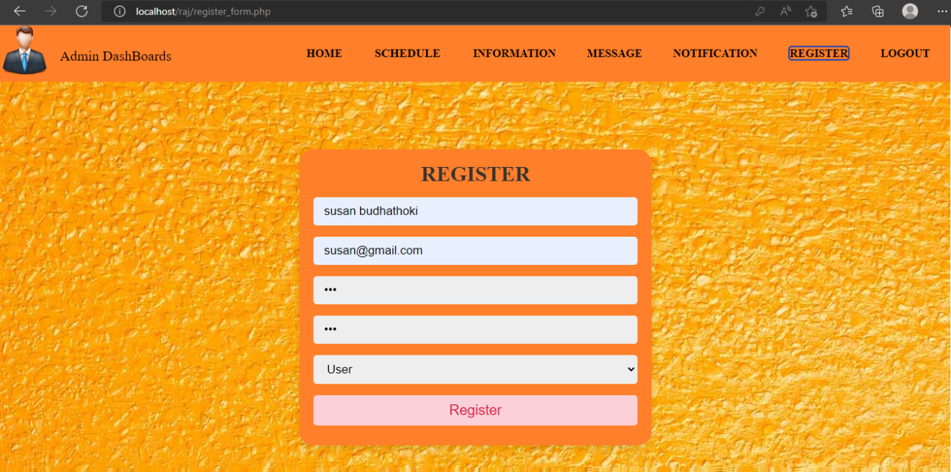

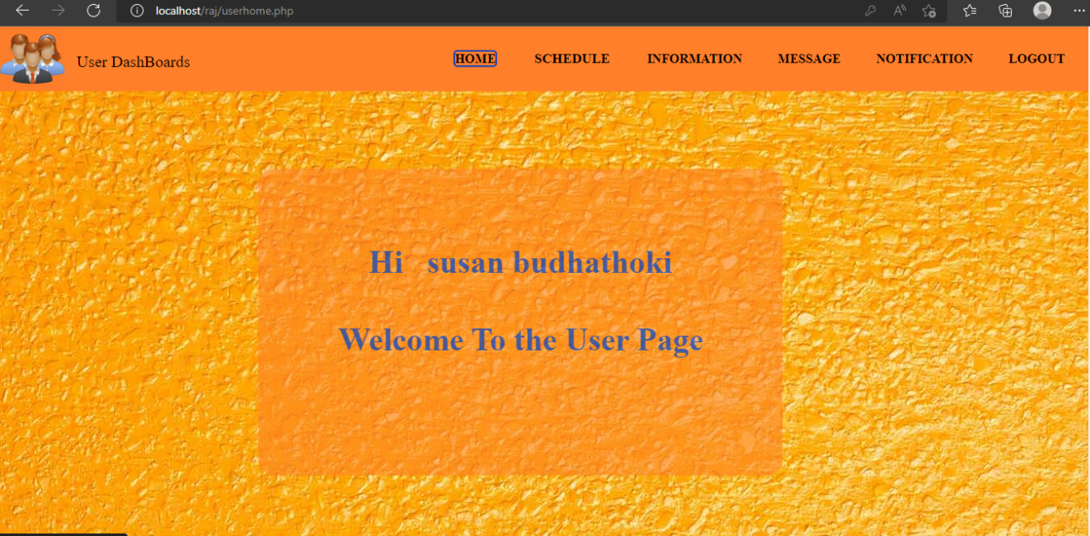

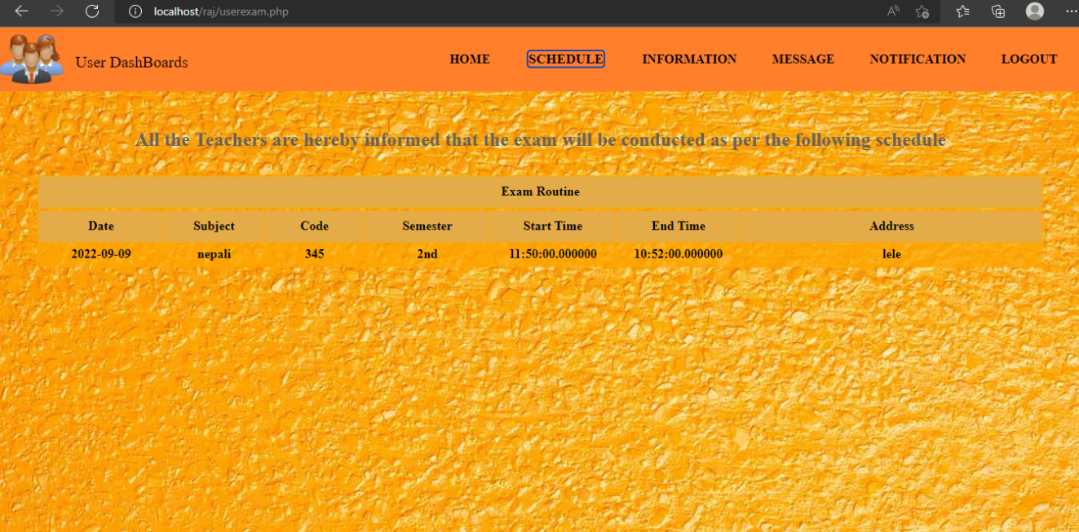

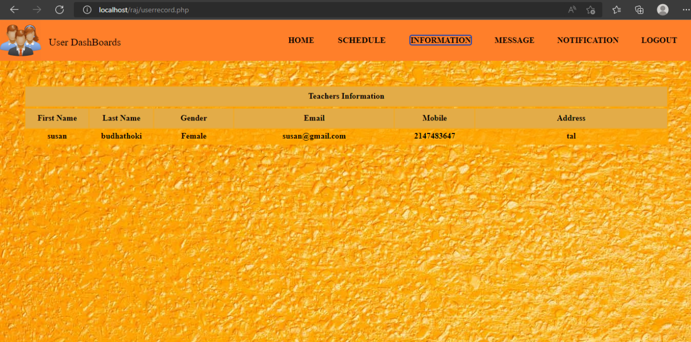

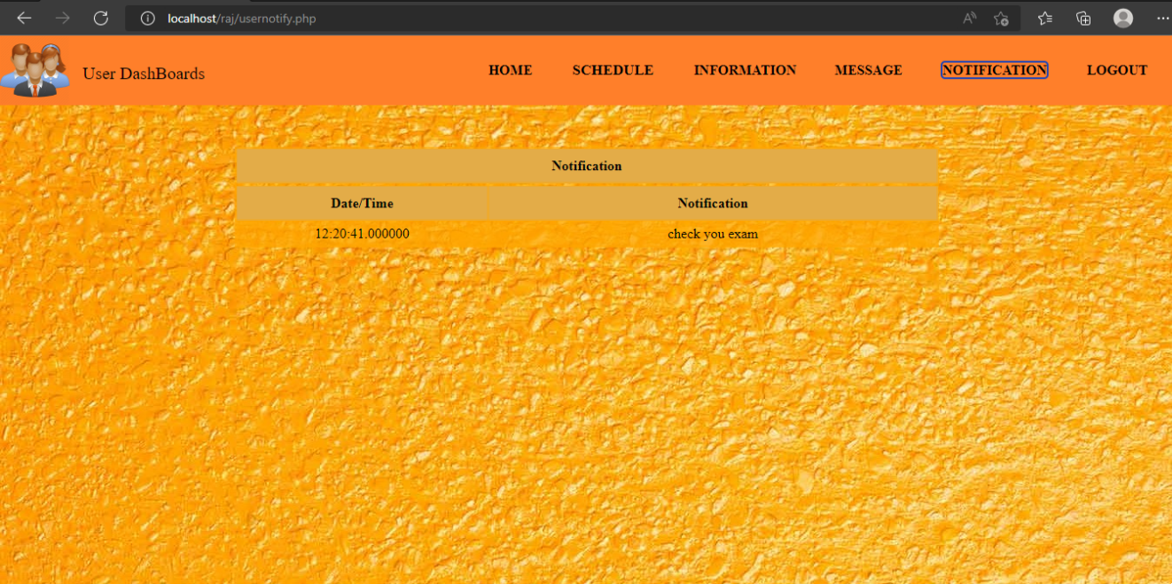

# References

## bibliography

1. “Code of Hammurabi,” *HISTORY*, 09-Nov-2009. [Online]. Available: https://www.history.com/topics/ancient-history/hammurabi. [Accessed: 28-Aug- 2022].

[2] “Sundials: Where time began,” *Farmers’ Almanac - Plan Your Day. Grow Your Life*, 04-Aug-2014. [Online]. Available: https://www.farmersalmanac.com/sundials-time-began-18870. [Accessed: 28- Aug-2022].

[3] manager.engage, “Ancient time measuring devices,” *Engage Learning*, 25-Jul- 2018. [Online]. Available: https://www.engage-online.com/2018/07/25/time- telling-time-measurement-in-the-past/. [Accessed: 28-Aug-2022]

[4] “About time,” Maa.org. [Online]. Available: https://www.maa.org/external_archive/devlin/devlin_12_99.html. [Accessed: 28- Aug-2022].

[5] S. Ward, “Time Management,” The Balance Small Business, 23-May-2004. [Online]. Available: https://www.thebalancesmb.com/time-management- 2948668. [Accessed: 28-Aug-2022].

[6] S. Ward, “Time Management,” *The Balance Small Business*, 23-May-2004. ` [Online]. Available: <https://www.thebalancesmb.com/time-management-> 2948668. [Accessed: 29-Aug-2022].

[7] “Setmore,” *Setmore.com*. [Online]. Available: https://www.setmore.com/. [Accessed: 28-Aug-2022].

1. “Education scheduling software and booking system - appointy,” *Online scheduling software*, 22-Nov- 2020. [Online]. Available: https://www.appointy.com/education-scheduling-software/. [Accessed: 28- Aug-2022].

[9] *LOVE It!* 2020.Clicky.com.[Online]. Available: https://www.softwareadvice.com/project-management/clickup-profile/

[10] *Researchgate.net*. [Online]. Available: https://www.researchgate.net/publication/313768789_The_Impact_of_Time_Man agement_on_the_Stu dents'_Academic_Achievements. [Accessed: 28-Aug-2022].

[11] B. Kim, S.-W. Lee, H. Hong, and K. Han, “Automated time manager: Effectiveness of self-regulation on time management through a smartphone application,” *IEEE Access*, vol. 7, pp. 90891–90903, 2019.

[12] L. L. C. Clever Prototypes, “Free storyboarding software — online storyboard creator,” *Storyboard That*. [Online]. Available: https://www.storyboardthat.com/. [Accessed: 28-Aug-2022].

[13] “Ideal modeling & diagramming tool for Agile team collaboration,” *Visual- paradigm.com*. [Online]. Available: https://www.visual-paradigm.com/. [Accessed: 28-Aug-2022].

[14] “XMind Cloud online editing now available,” *Xmind.net*. [Online]. Available: https://www.xmind.net/newsletter/july-2016-editonline/?ref. [Accessed: 28-Aug- 2022].

[15] “StarUML,” *Staruml.io*. [Online]. Available: https://staruml.io/. [Accessed: 28- Aug-2022].

[16] “Sublime Text - the sophisticated text editor for code, markup and prose,” *Sublimetext.com*. [Online]. Available: https://www.sublimetext.com/. [Accessed: 28-Aug-2022].

[17] *Projectlibre.com*. [Online]. Available: https://www.projectlibre.com/. [Accessed: 28-Aug-2022].

[18] “Balsamiq cloud,” *Balsamiq.cloud*. [Online]. Available: https://balsamiq.cloud/sxw5bbr/projects. [Accessed: 28-Aug-2022].

[19] “WPS office - free office download for PC & mobile, alternative to MS office,” *WPS*. [Online]. Available: https://www.wps.com/. [Accessed: 28- Aug- 2022].

[20] “About YouTube,” *About.youtube*. [Online]. Available: https://about.youtube/. [Accessed: 28-Aug- 2022].

[21] “Google Chrome - download the fast, secure browser from Google,” *Google.com*. [Online]. Available: https://www.google.com/chrome/. [Accessed: 28-Aug- 2022].

[22] Dansimp, “Frequently asked questions (FAQ) for IT pros,” *Microsoft.com*. [Online]. Available: https://docs.microsoft.com/en-us/microsoft- edge/deploy/microsoft-edge-faq. [Accessed: 28-Aug-2022].

[23] “Introduction to HTML,” in *Web Application Design and Implementation*, IEEE, 2011.

[24] “JavaScript tutorial,” *W3schools.com*. [Online]. Available: https://www.w3schools.com/js/. [Accessed: 28-Aug-2022].

[25] “What is CSS?,” *Tutorialspoint.com*. [Online]. Available: https://www.tutorialspoint.com/css/what_is_css.htm. [Accessed: 28-Aug-2022].

[26] “PHP introduction,” *W3schools.com*. [Online]. Available: https://www.w3schools.com/php/php_intro.asp. [Accessed: 28-Aug-2022].

1. “What is Ajax?,” in *Ajax in Oracle JDeveloper*, Berlin, Heidelberg: Springer Berlin Heidelberg, 2008, pp. 1–17.

[28] “JQuery introduction,” *W3schools.com*. [Online]. Available: https://www.w3schools.com/jquery/jquery_intro.asp. [Accessed: 28-Aug-2022].

[29] “PHP MySQLi functions,” *W3schools.com*. [Online]. Available: https://www.w3schools.com/pHP/php_ref_mysqli.asp. [Accessed: 28-Aug-2022].

1. “Levels in data flow diagrams (DFD),” *GeeksforGeeks*, 18-Mar-2019. [Online]. Available:https://www.geeksforgeeks.org/levels-in-data-flow- diagrams-dfd/. [Accessed: 08-Sep-2022].

[31] S. Naik, “What is XAMPP?,” *EDUCBA*, 02-Aug-2021. [Online]. Available: http://educba.com/what-is-xampp/. [Accessed: 08-Sep-2022].

# 